Changed Face of Industry after Pandemic and Surviving in Industry

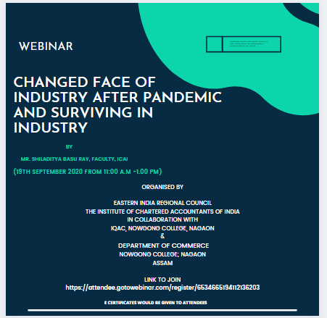
Seminar Report: "Changed Face of Industry after Pandemic and Surviving in Industry"
This seminar explored the profound impact of the COVID-19 pandemic on various industries. Key discussions included:
- Digital Transformation: Increased reliance on technology, remote work, and e-commerce.
- Supply Chain Disruptions: Challenges in logistics, global trade, and raw material sourcing.
- Consumer Behavior Shifts: Changing preferences, increased demand for online services, and focus on sustainability.
- Adaptability and Resilience: Strategies for businesses to survive and thrive in the new normal, including innovation, diversification, and customer-centric approaches.

