SEMINAR ON HOW A CAREER ON CIVIL SERVICE AND STRATEGIES TO CRACK
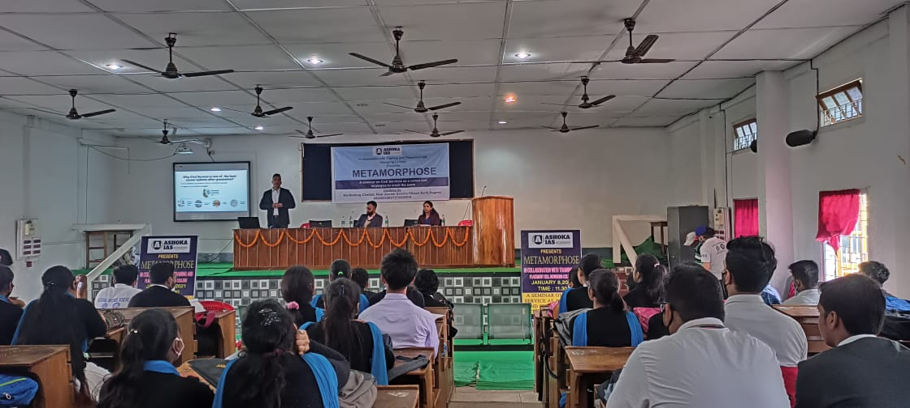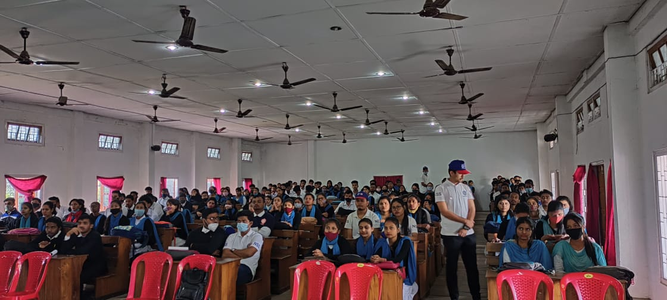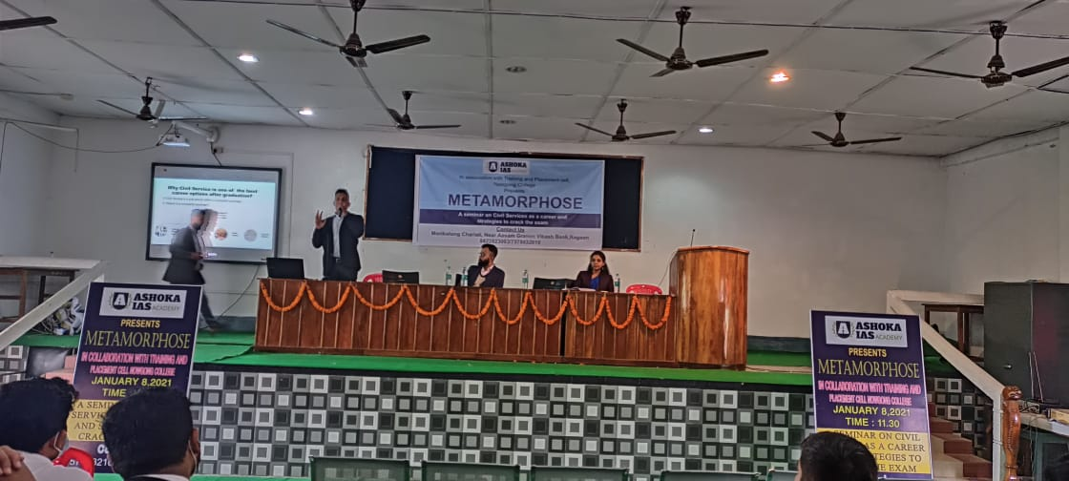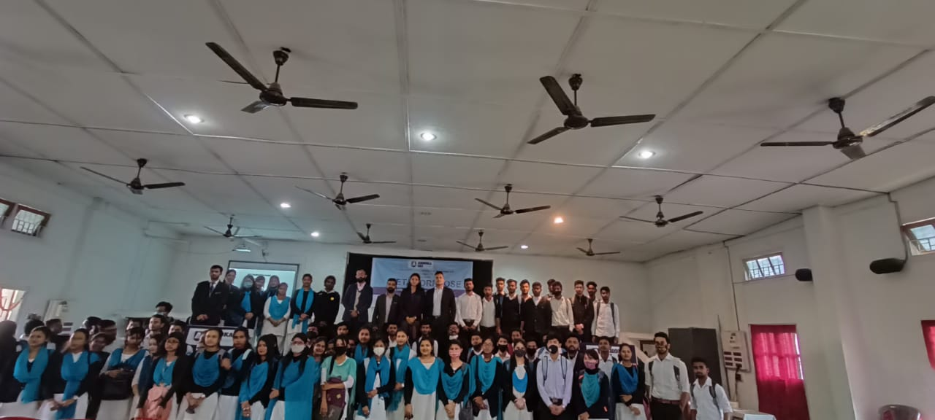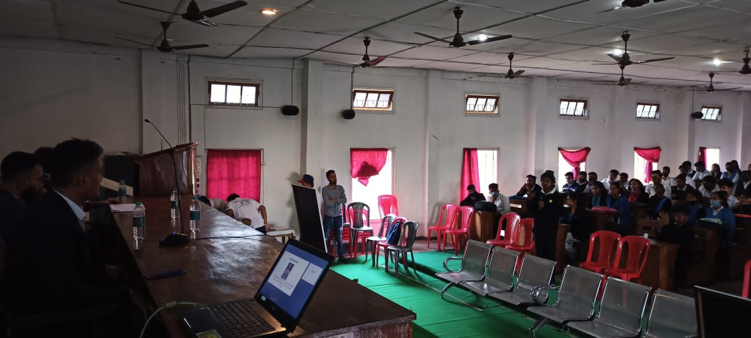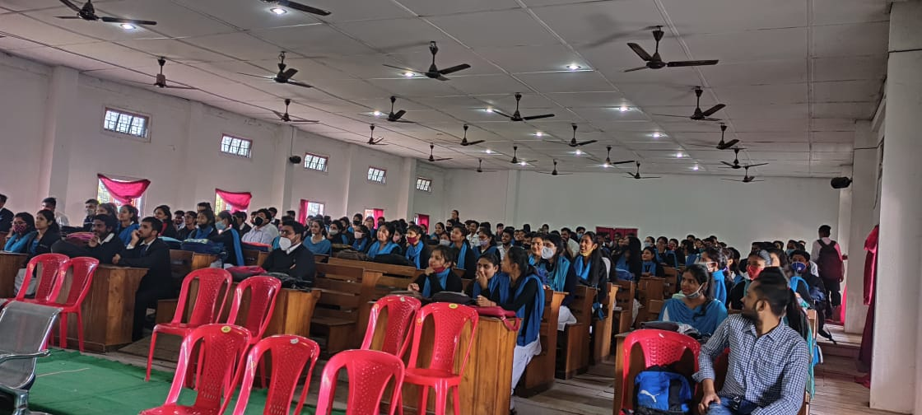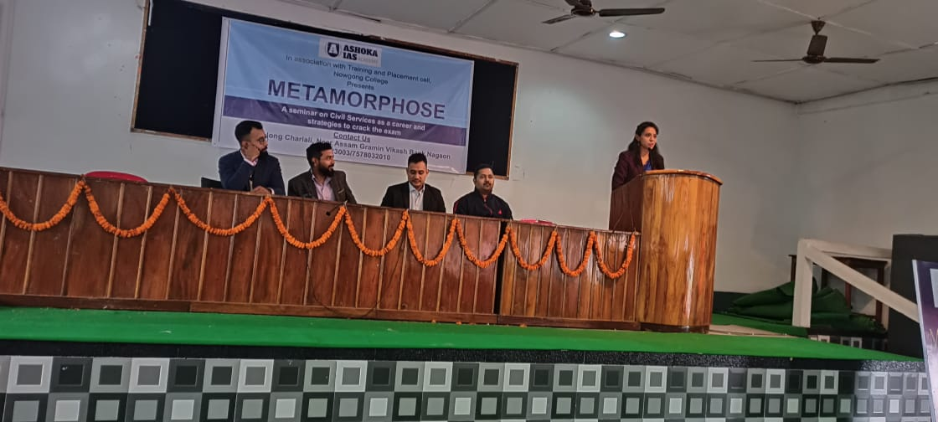
The seminar on "A Career in Civil Service and Strategies to Crack" provided valuable insights into the Indian Administrative Service (IAS) and other civil services. Attendees learned about the roles and responsibilities of civil servants, the eligibility criteria, and the rigorous selection process. The seminar also highlighted the importance of developing a strong foundation in current affairs, history, geography, and other relevant subjects. Effective time management, consistent study habits, and a positive mindset were emphasized as crucial strategies for success in the civil services examinations. The seminar concluded with a Q&A session where aspiring candidates had the opportunity to interact with experienced civil servants and address their queries

