How to prepare for Competitive Exams and Interview Skills
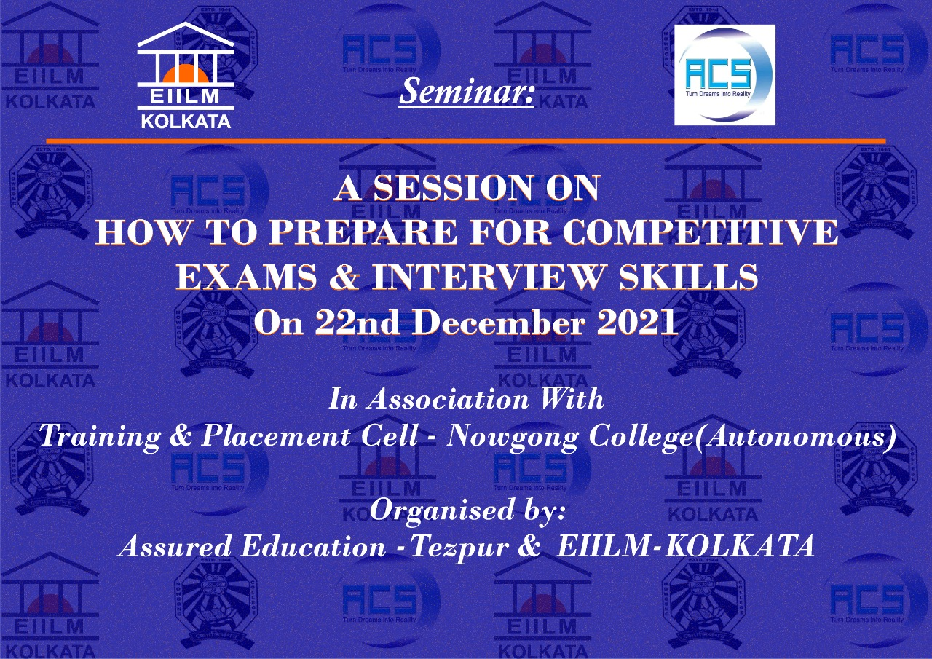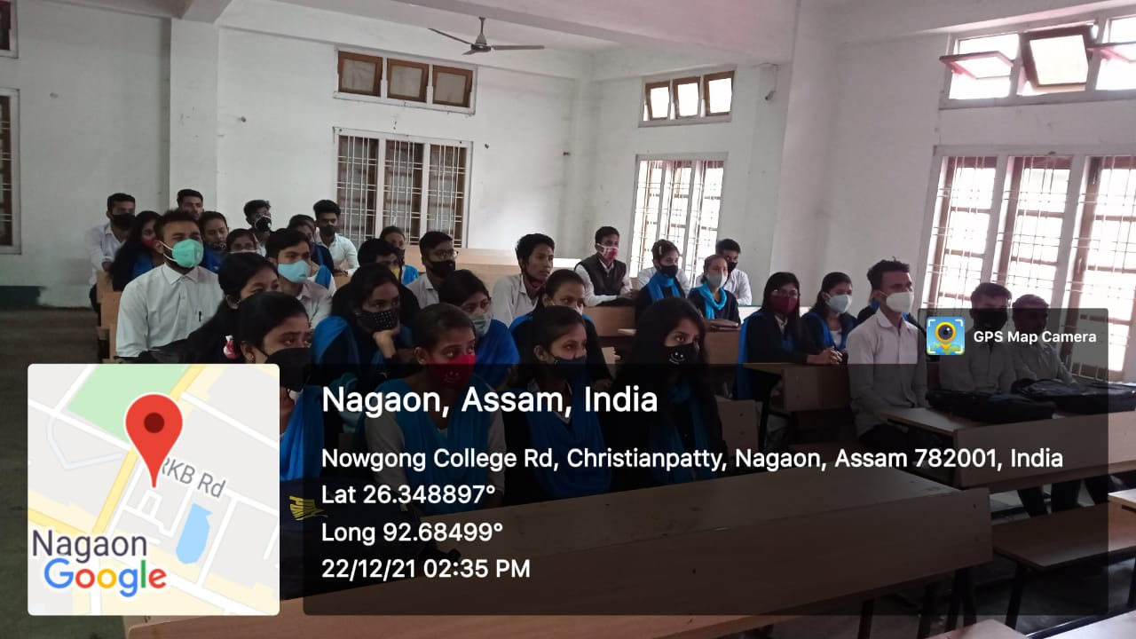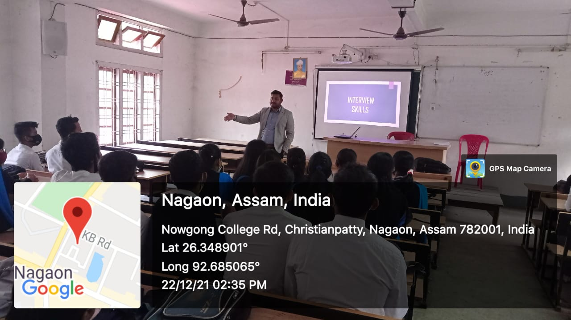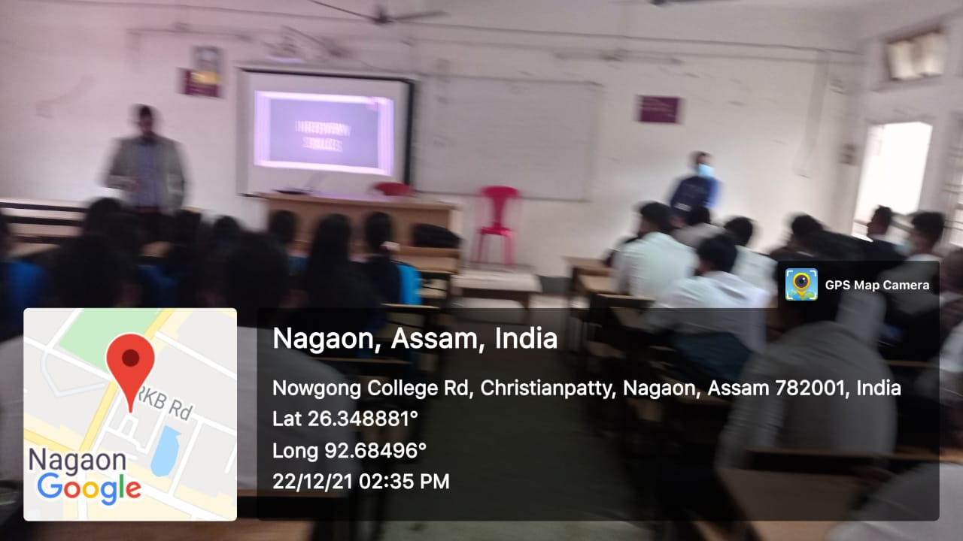

A seminar on "How to Prepare for Competitive Exams and Interview Skills" was conducted on [22/12/2021], aimed at guiding students toward success in competitive exams and interviews. Expert speakers shared effective strategies for exam preparation, including time management, syllabus analysis, and mock test practice. The session also emphasized building strong communication skills, confidence, and body language for interviews. Interactive discussions and live demonstrations engaged participants, providing practical tips for personal and professional growth. Attendees left with enhanced clarity and motivation, appreciating the seminar's relevance in navigating the competitive landscape.

