Ideathon Competition in Collaboration with Assam Startup

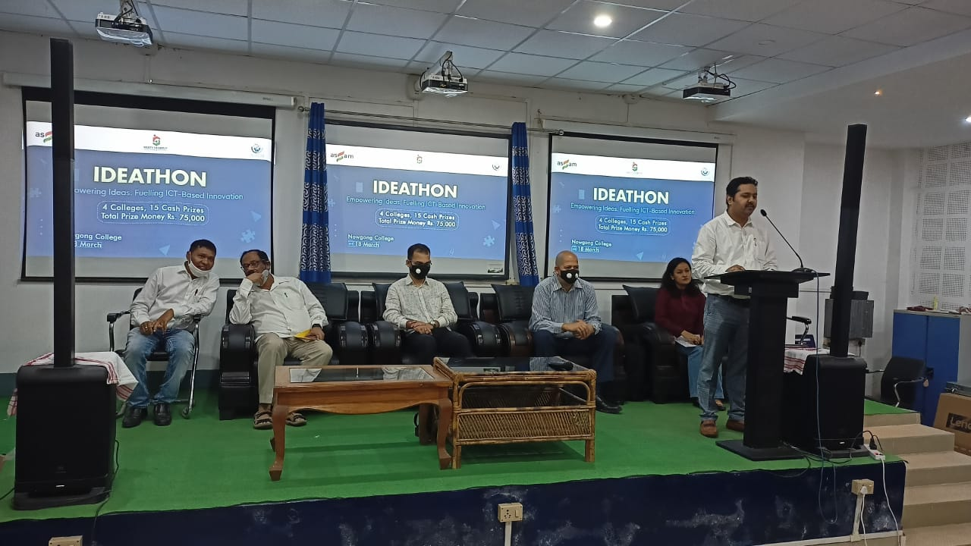
The Ideathon Competition, organized in collaboration with Assam Startup, provided a dynamic platform for students to showcase innovative ideas and entrepreneurial skills. Held on [insert date], the seminar brought together aspiring young minds to address pressing challenges across diverse sectors such as technology, agriculture, and sustainable development. Participants pitched creative solutions to an expert panel comprising industry leaders and startup mentors. The event fostered critical thinking, collaboration, and practical business insights, empowering students to transform ideas into actionable projects. The initiative reinforced Assam Startup's commitment to nurturing the region's entrepreneurial ecosystem and promoting a culture of innovation among youth.

