ONE WEEK PROGRAMME ON DEVELOPING SOFT SKILLS BY TRIBENI BHATTACHARYA, OPTIMISTA LEARNING HUB, GUWAHATI

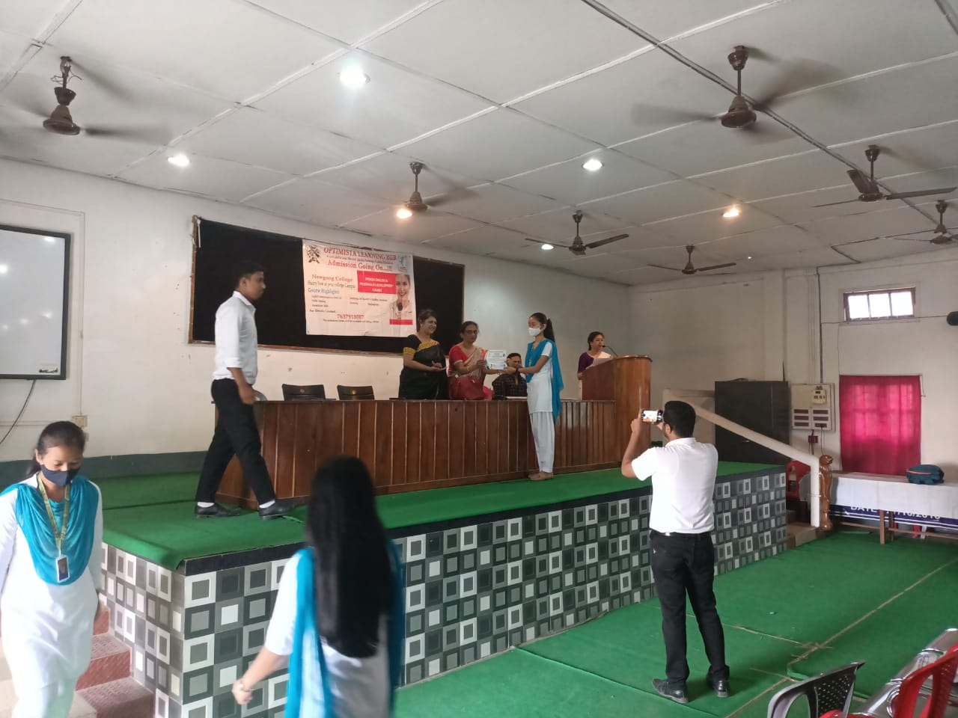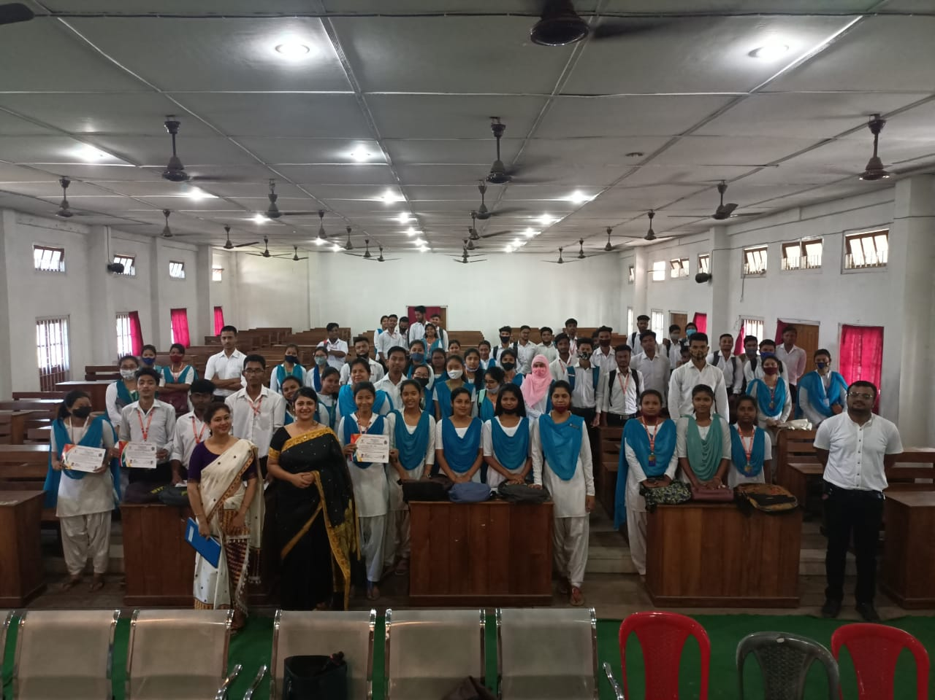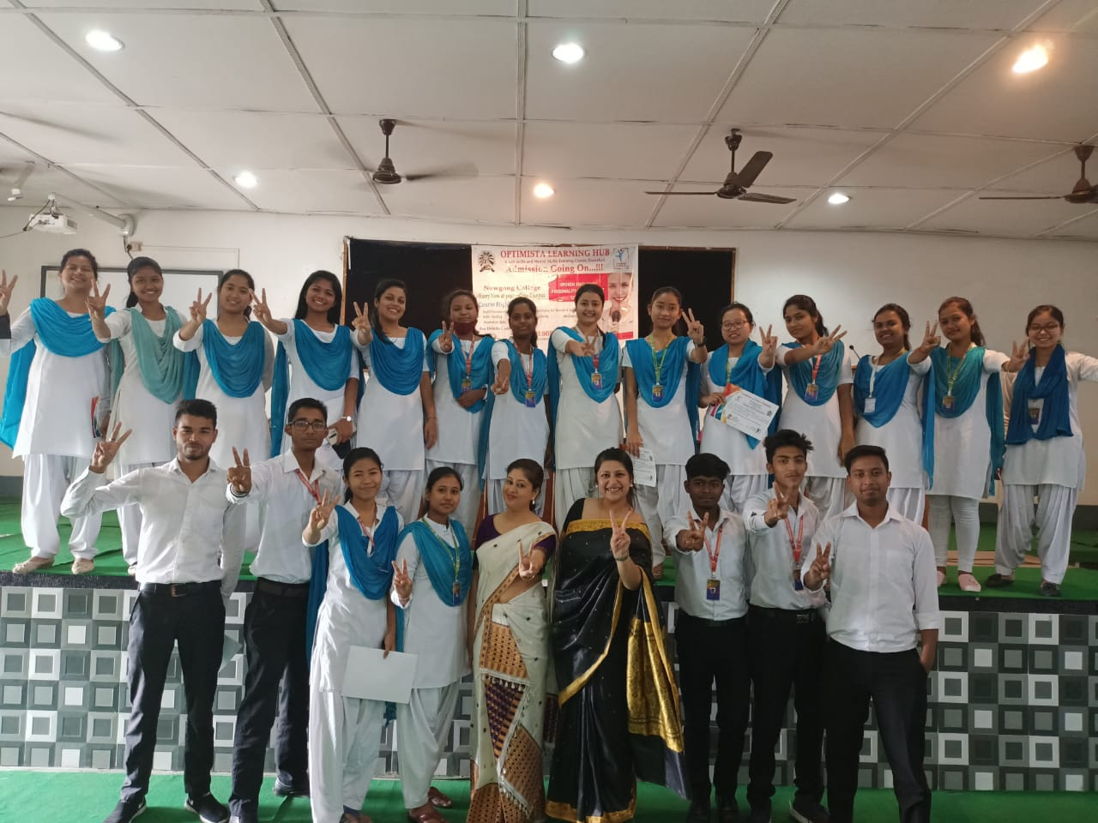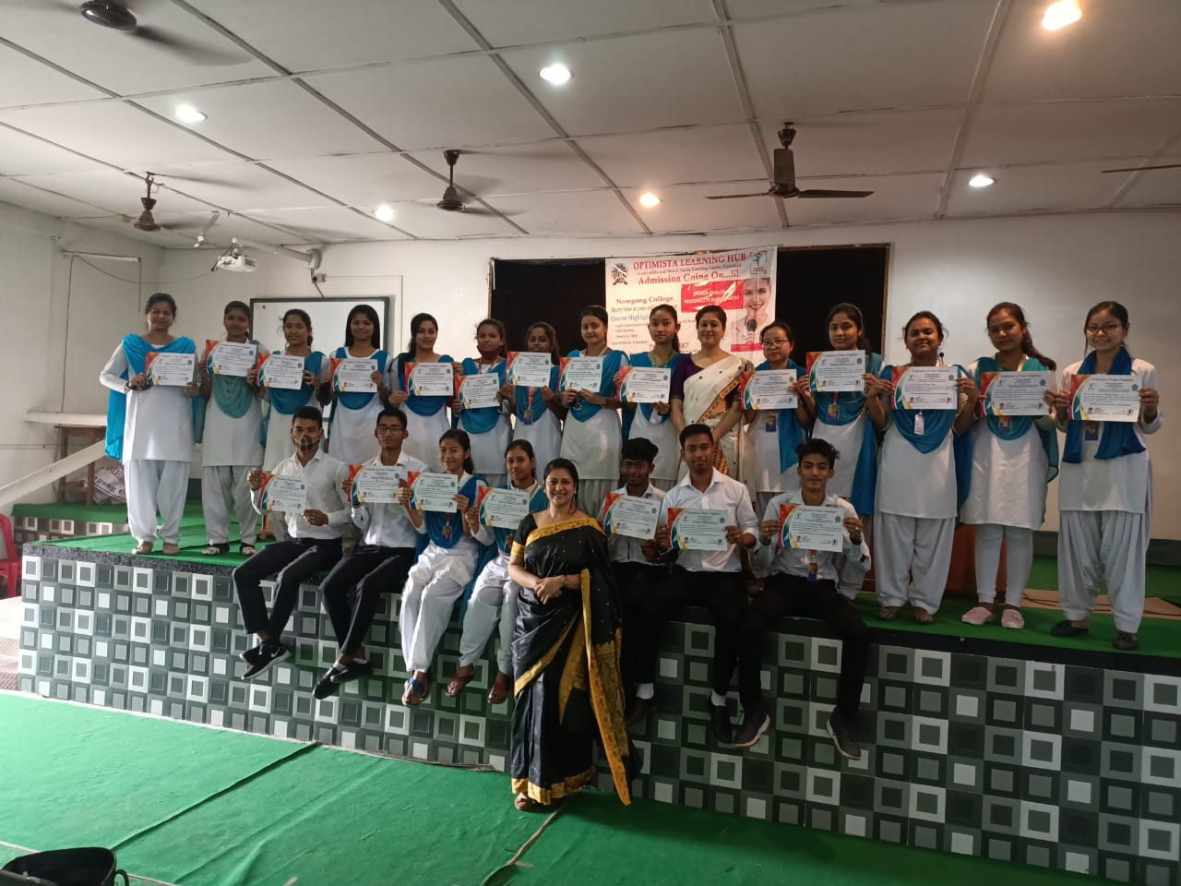

A one-week programme on developing soft skills, conducted by Tribeni Bhattacharya of Optimista Learning Hub, Guwahati, successfully concluded with resounding participation. The sessions focused on enhancing communication, teamwork, leadership, and emotional intelligence, aiming to empower participants with essential interpersonal skills. Through interactive workshops, role-playing, and engaging activities, attendees gained practical insights into building confidence and professional competence. Tribeni Bhattacharya's expertise and engaging delivery made the sessions highly impactful. The programme emphasized the significance of soft skills in personal and professional growth, leaving participants motivated and better equipped to handle real-world challenges. Feedback highlighted the event’s relevance and effectiveness.

