How to prepare for Banking Examinations: Vivekananda Academy
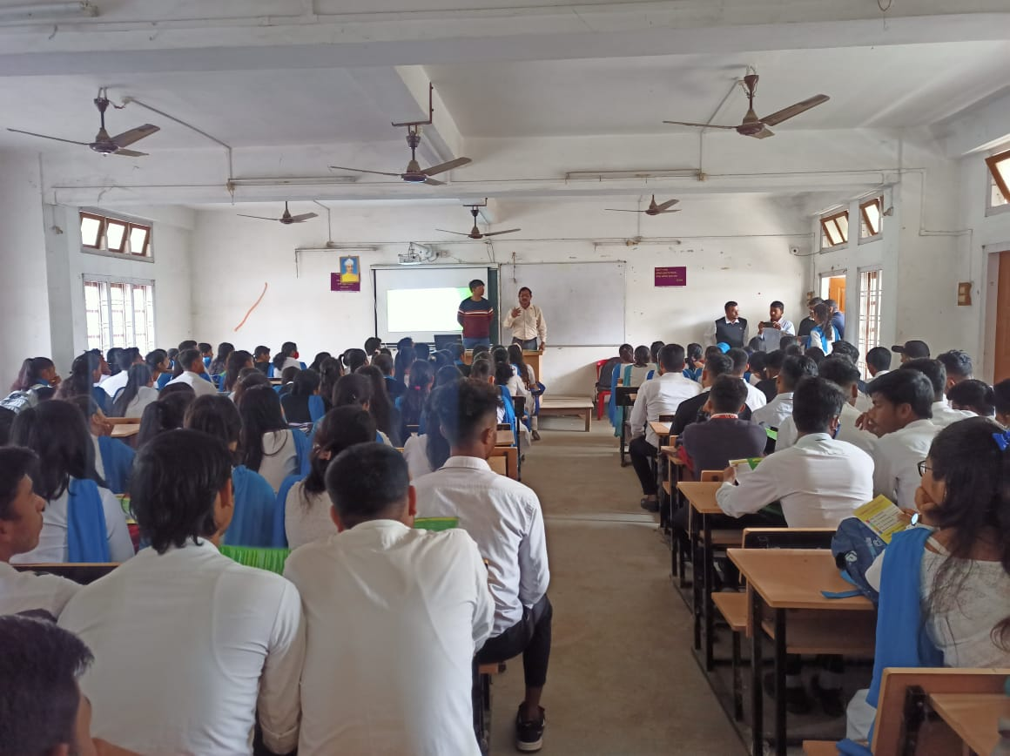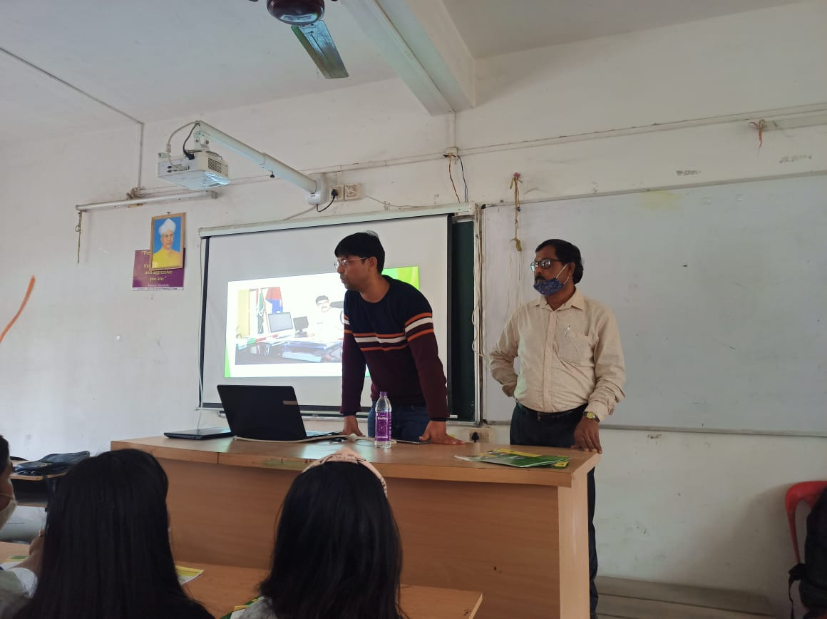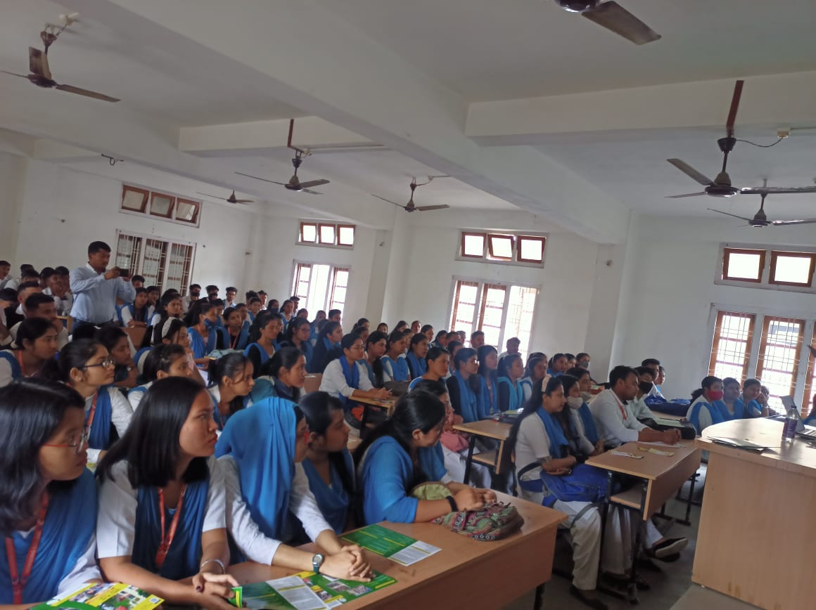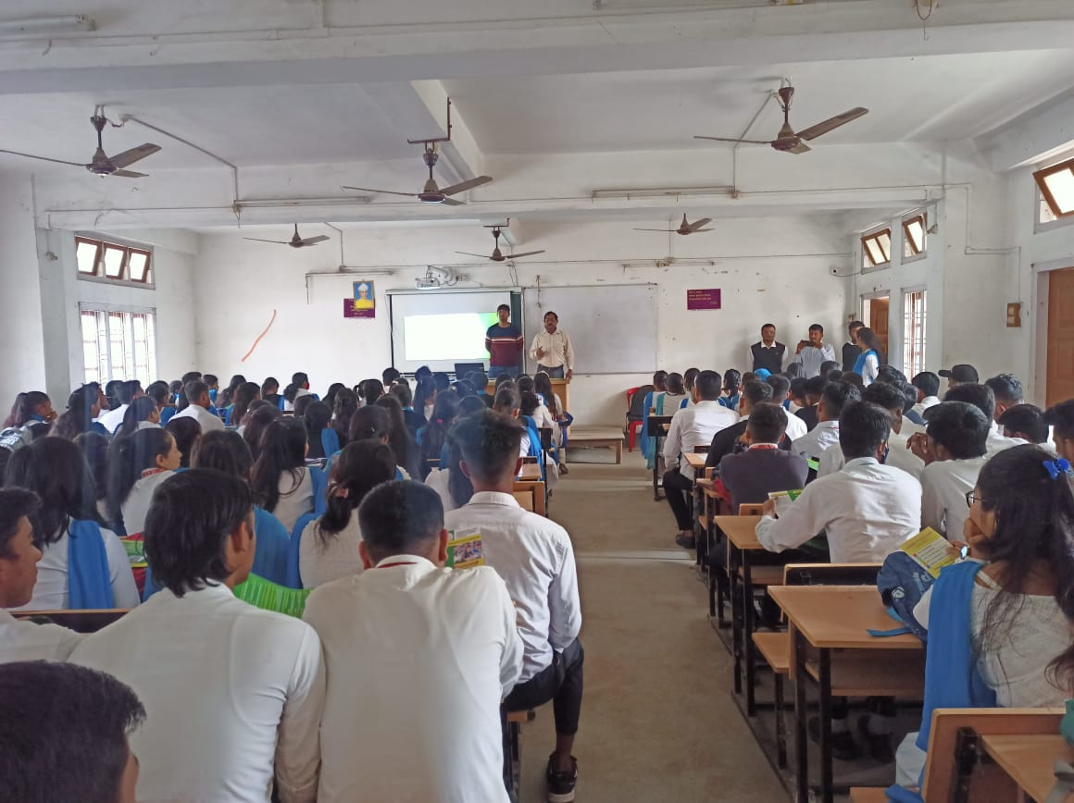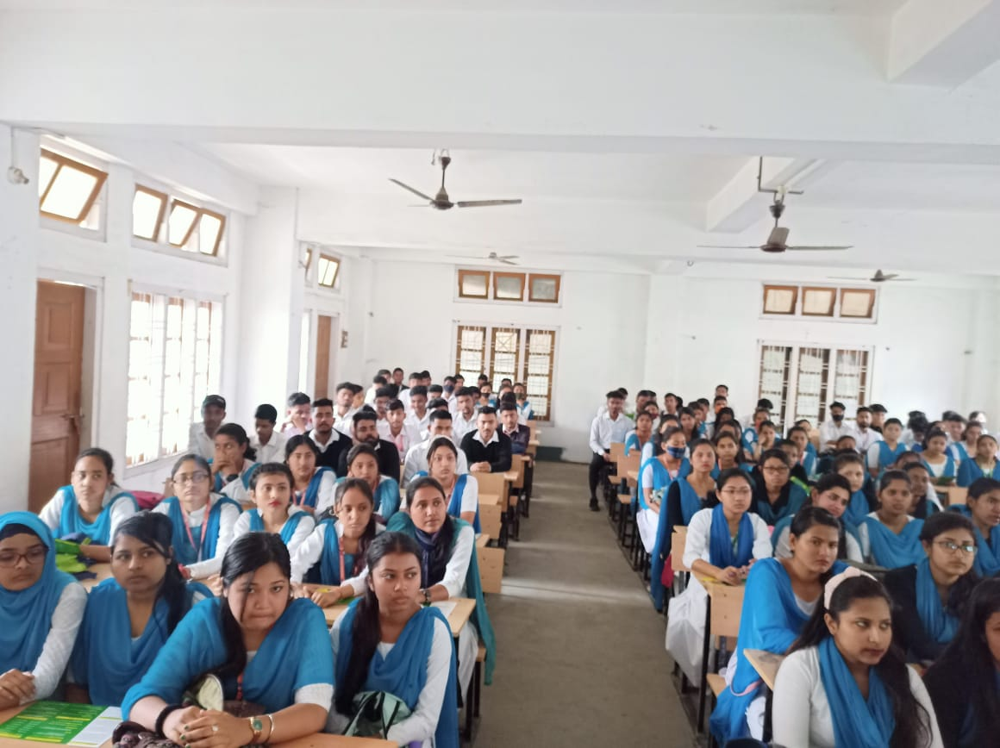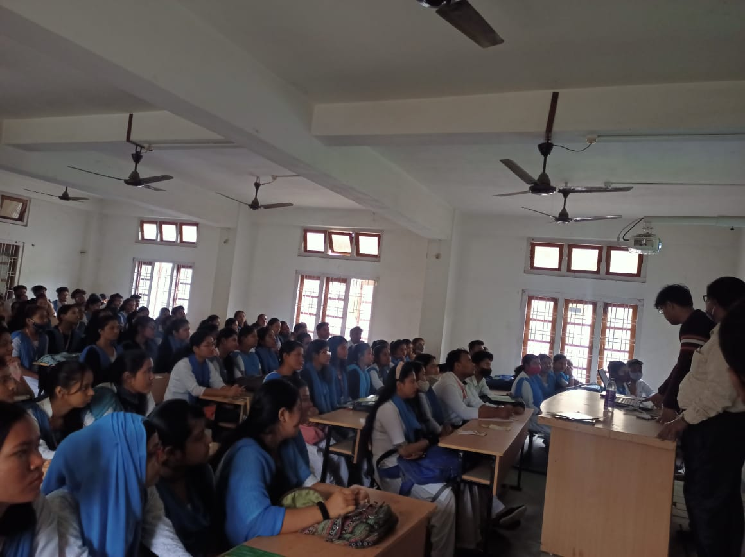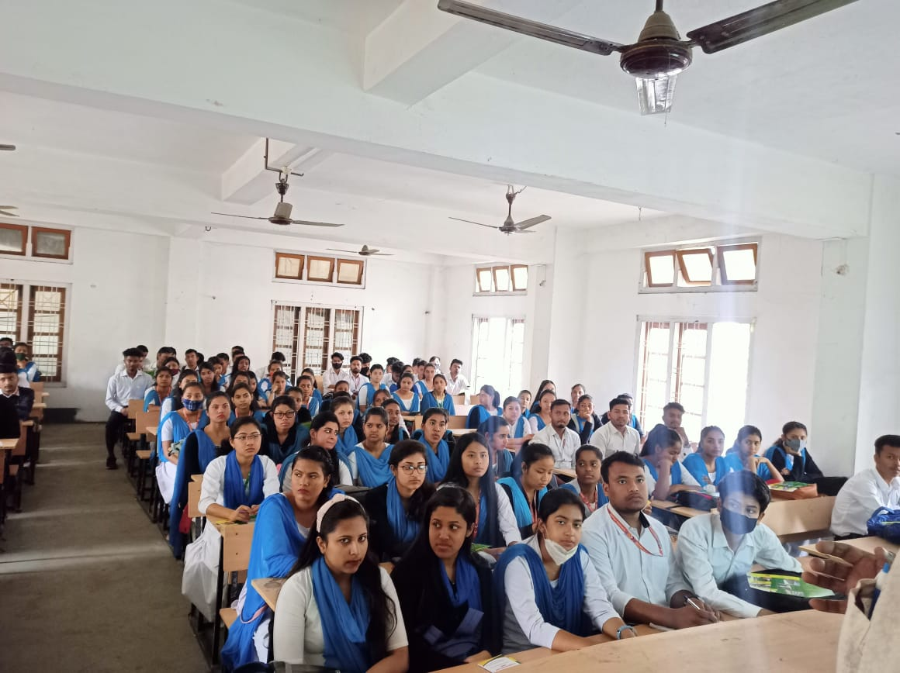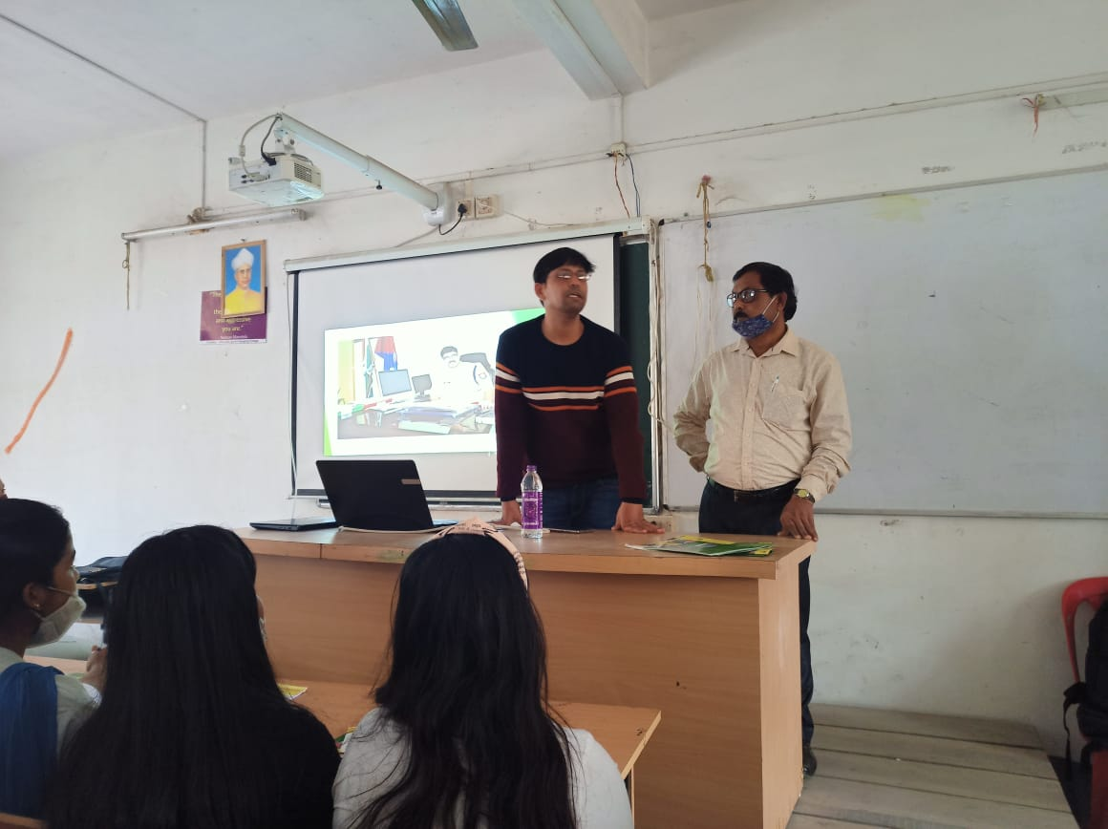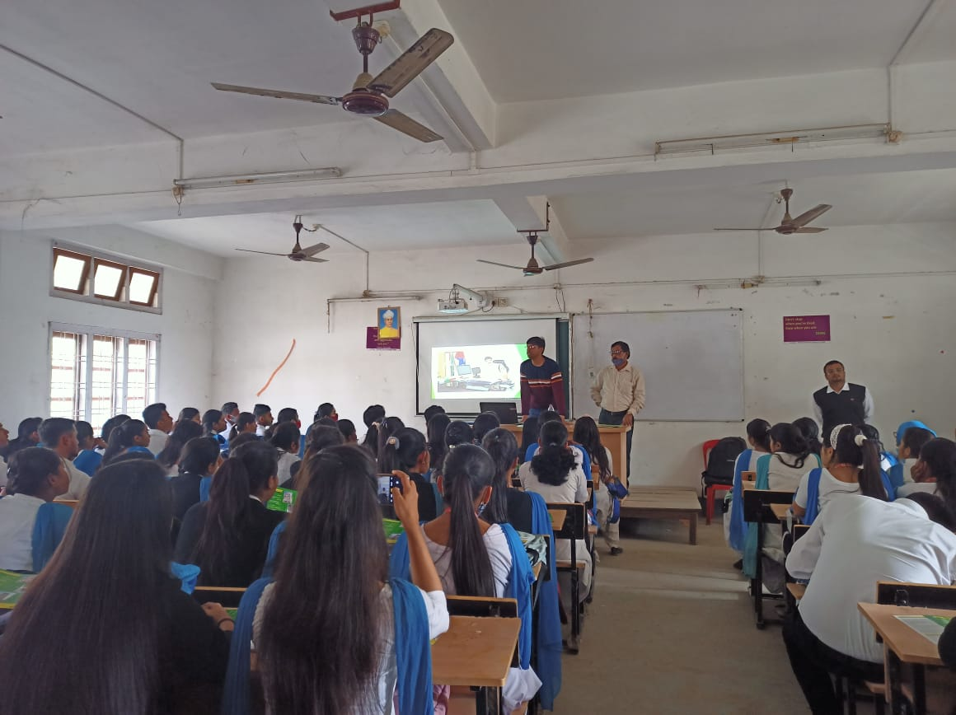

A seminar on "How to Prepare for Banking Examinations" was held on [date], aiming to guide aspirants through effective strategies for success. Renowned speakers emphasized understanding the syllabus, mastering time management, and focusing on core subjects such as quantitative aptitude, reasoning, and English. Tips on current affairs preparation, regular mock tests, and analyzing results were shared. The session also highlighted the importance of maintaining consistency and a positive mindset. Attendees interacted actively, raising queries about preparation methods and resources. The seminar concluded with a motivational address encouraging participants to stay disciplined and committed to their goals.

