INVESTORS AWARNESS PROGRAMME

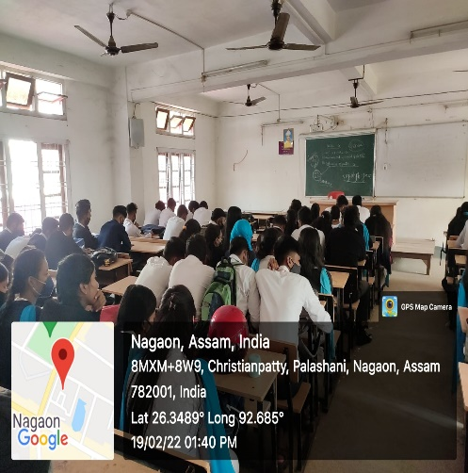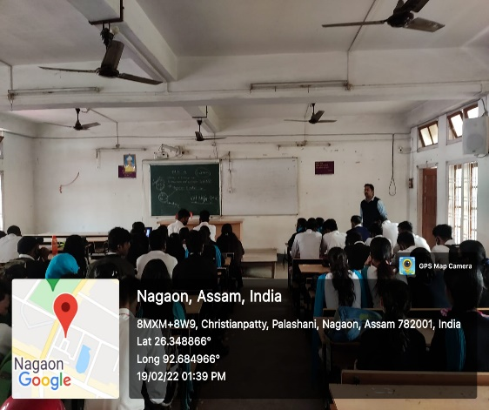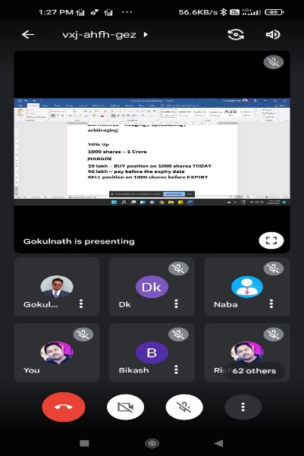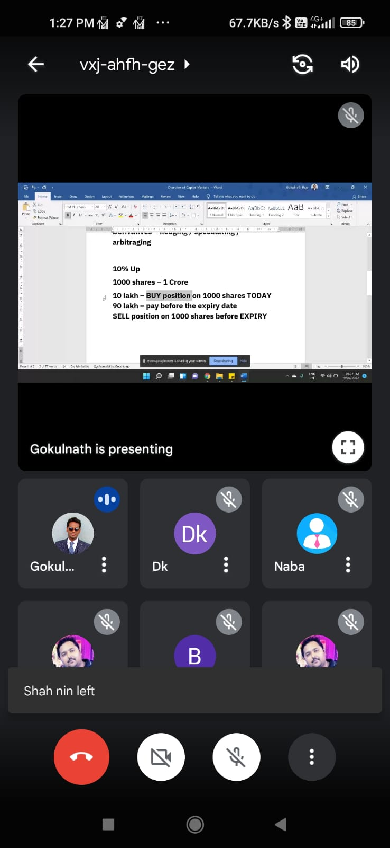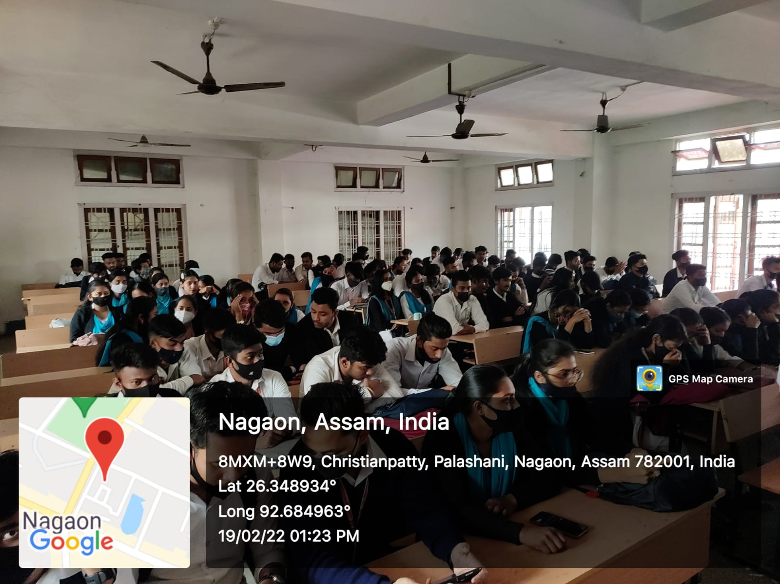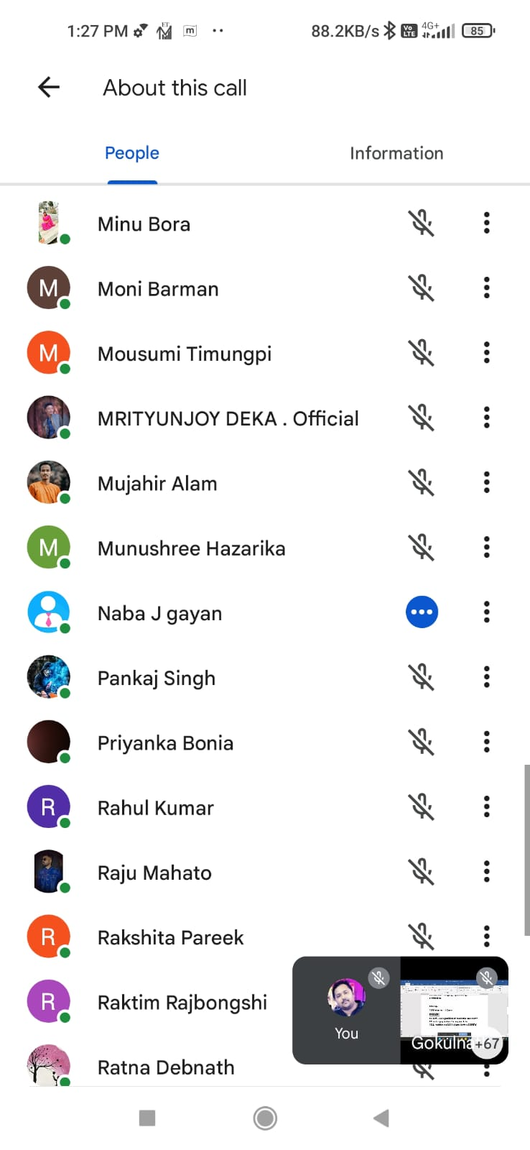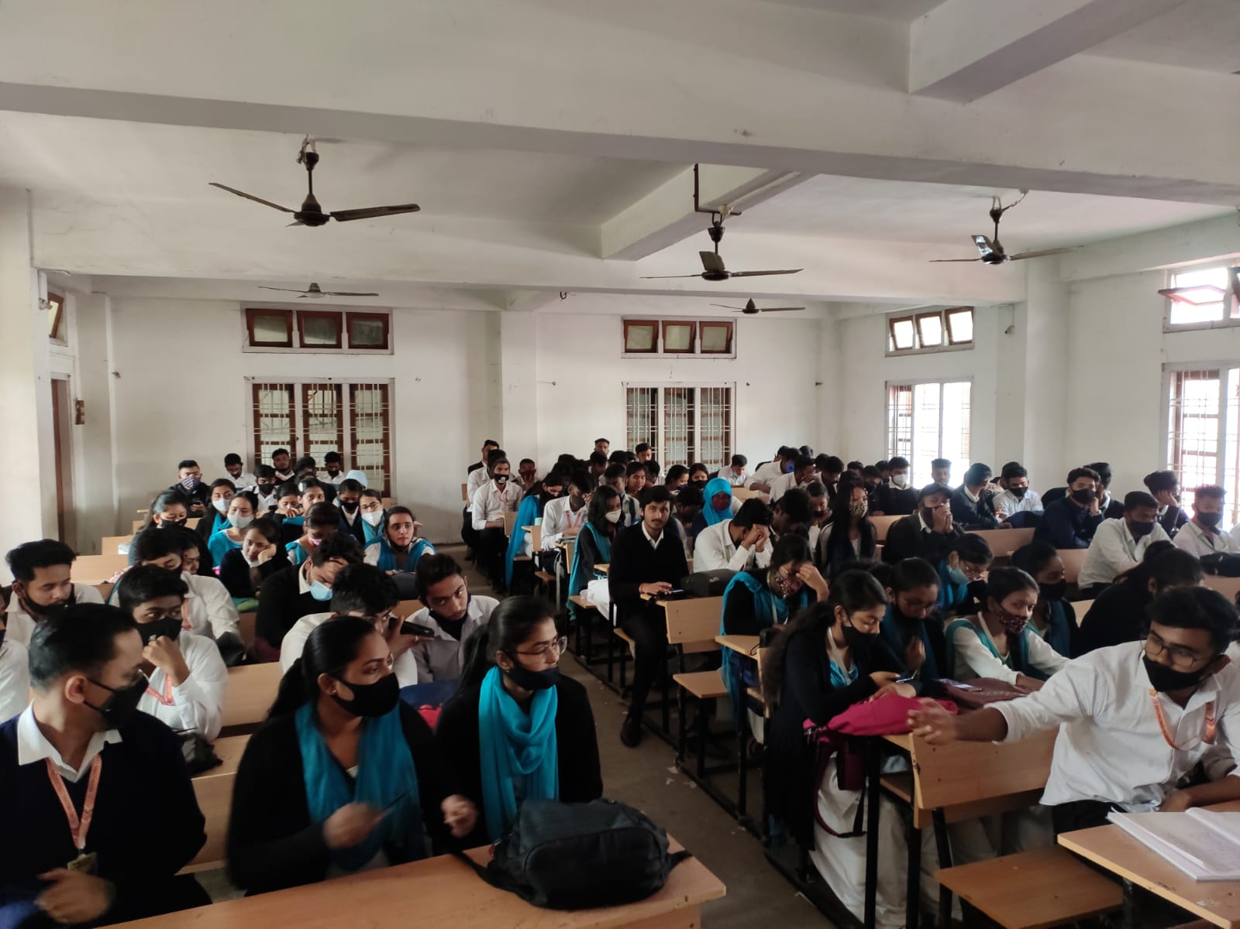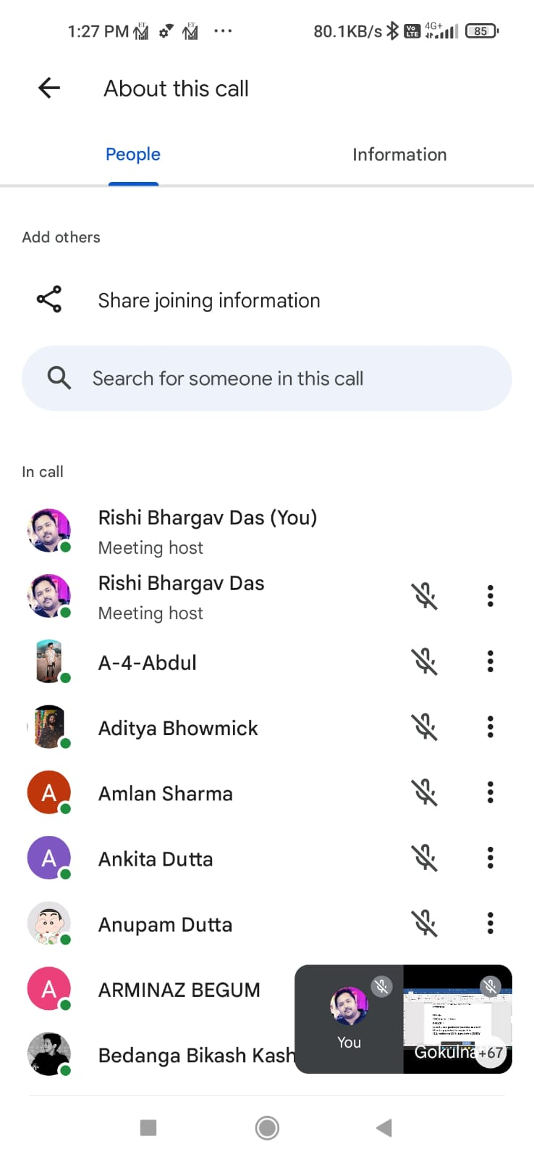
The National Stock Exchange (NSE) conducted a seminar on Investor Awareness to promote financial literacy and educate individuals on smart investment practices. The seminar focused on key topics such as the importance of stock markets, investment strategies, risk management, and investor rights. Industry experts emphasized transparency, informed decision-making, and avoiding market frauds. Participants gained insights into tools for portfolio diversification and the role of regulatory frameworks. The initiative aimed to empower investors, particularly beginners, to make well-informed financial choices. The session concluded with a Q&A segment, addressing participants' queries and encouraging responsible investment behavior.

