"Creative Ideas for Creative Entrepreneurs – A Business Idea Competition"
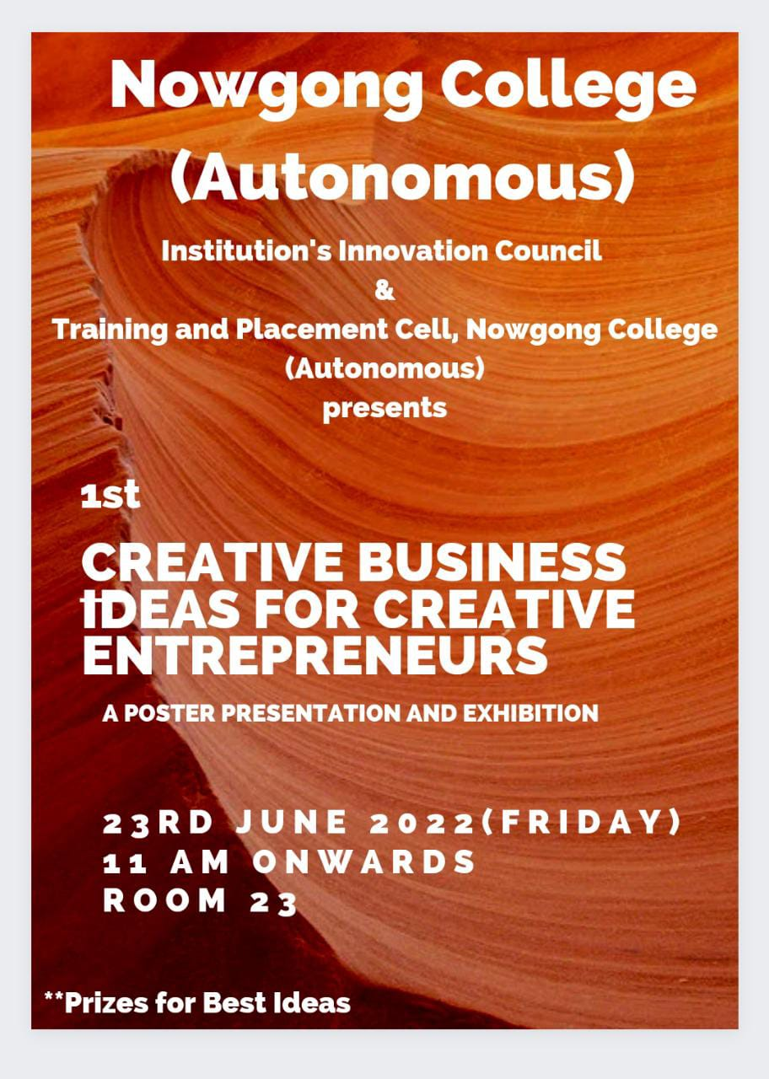

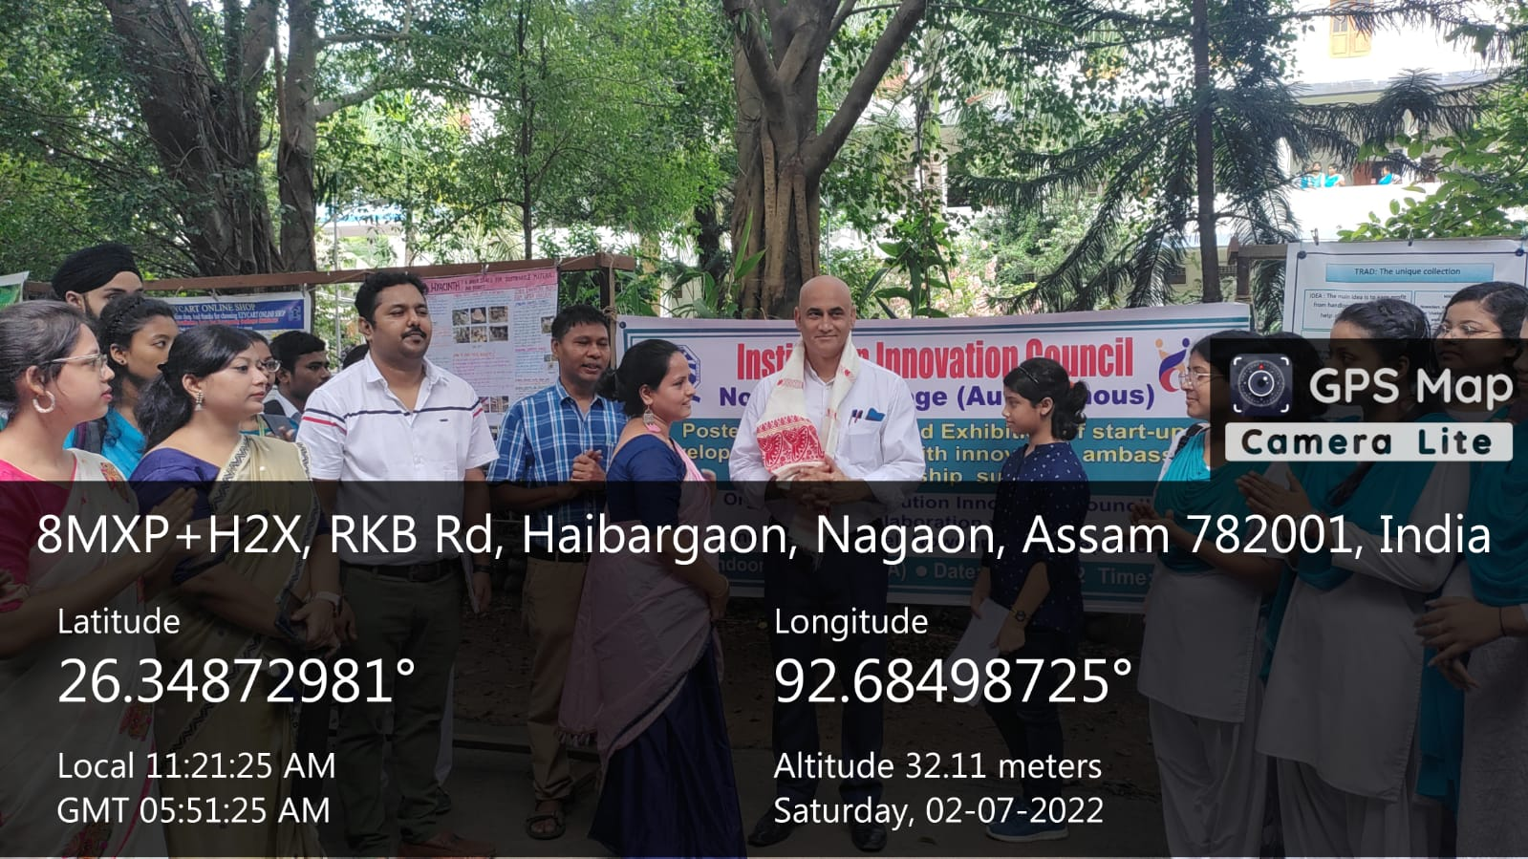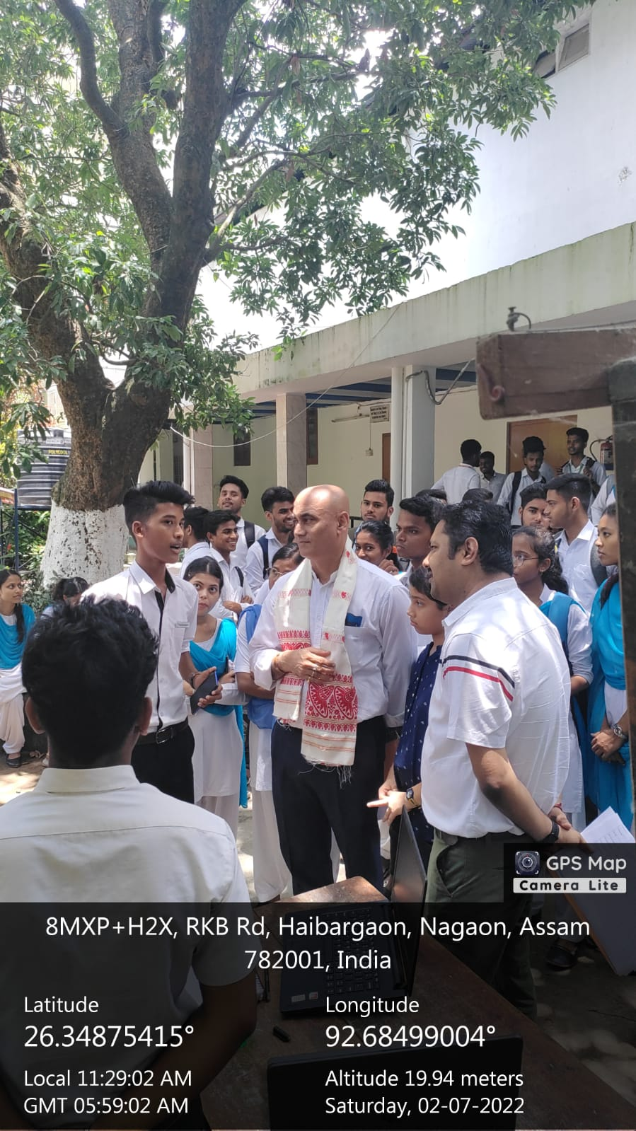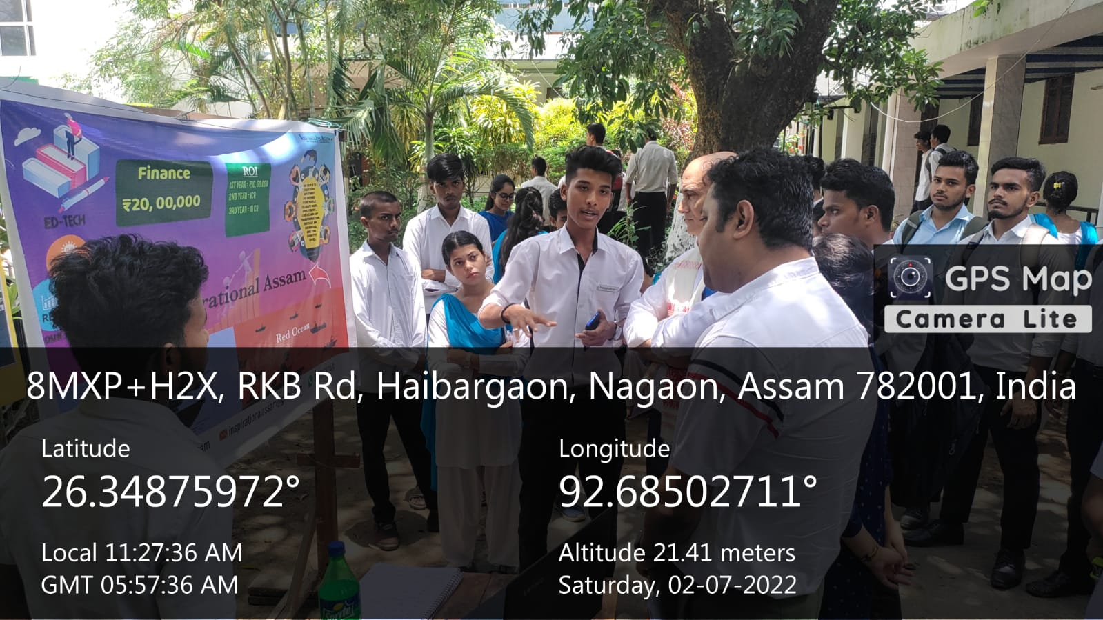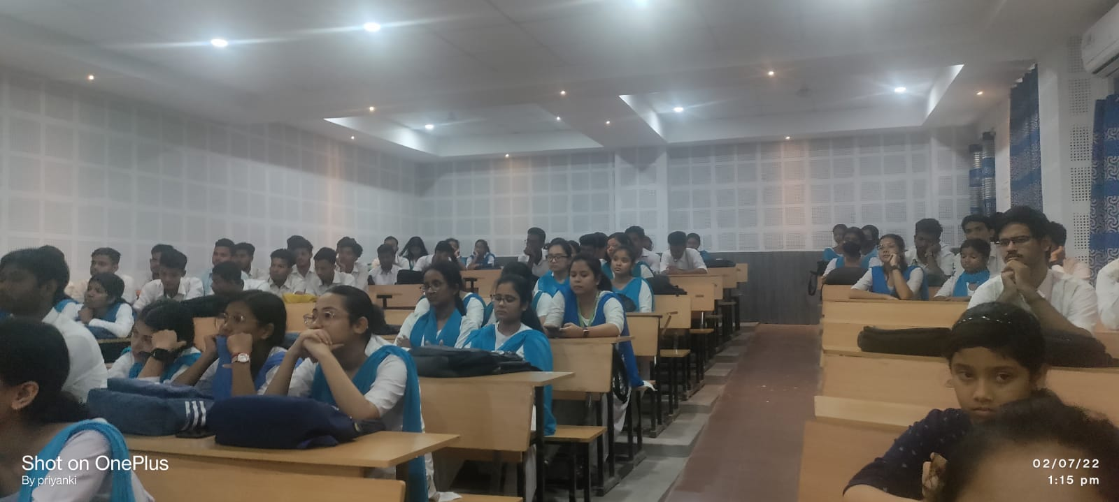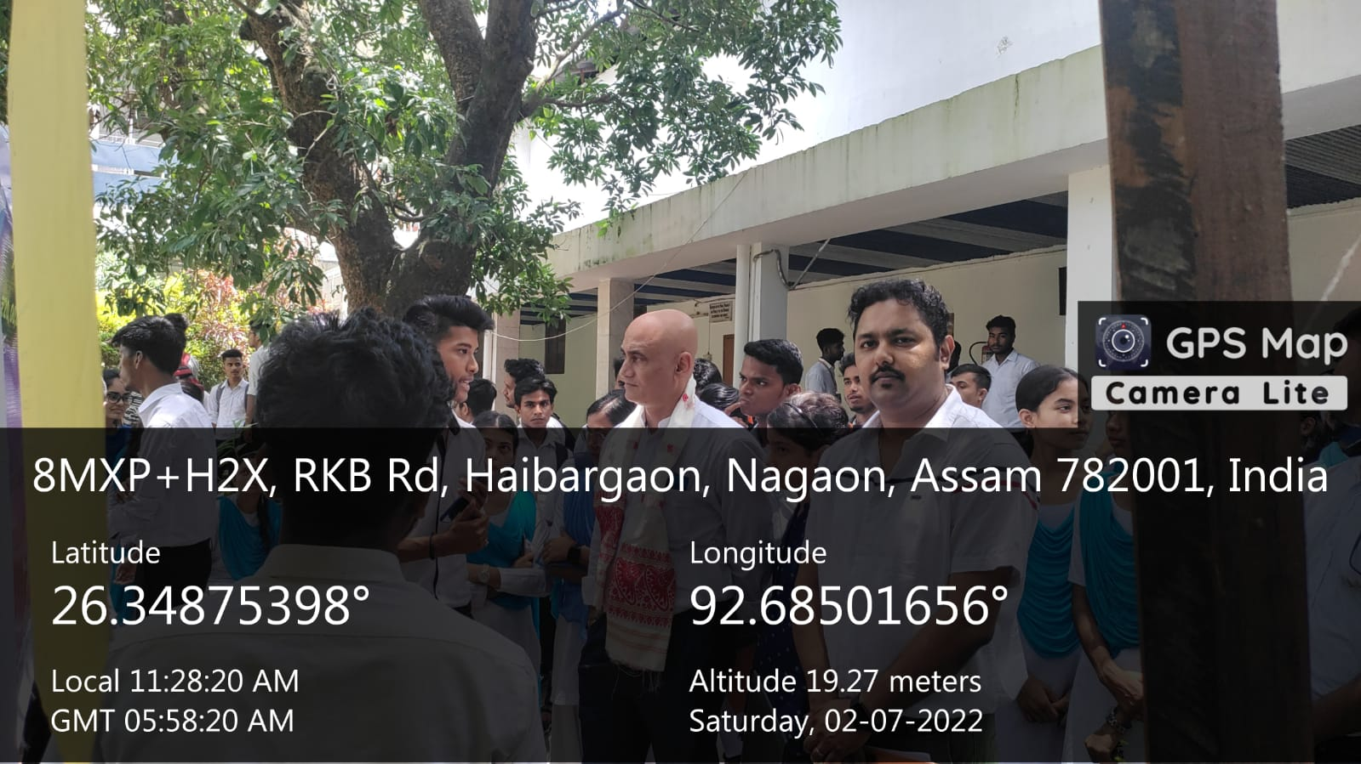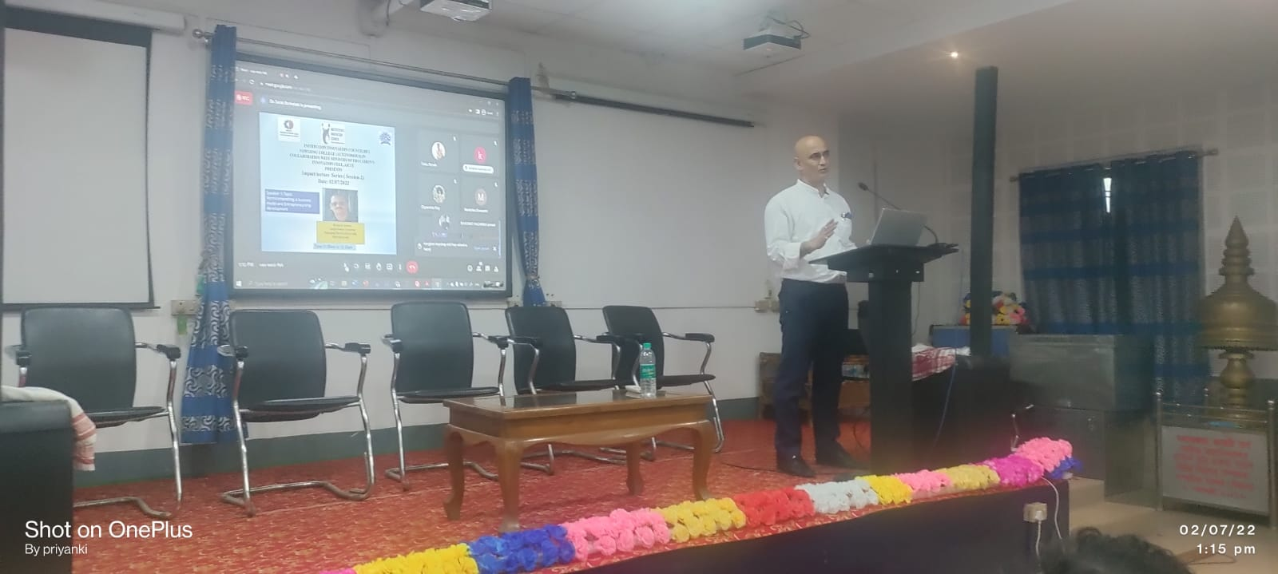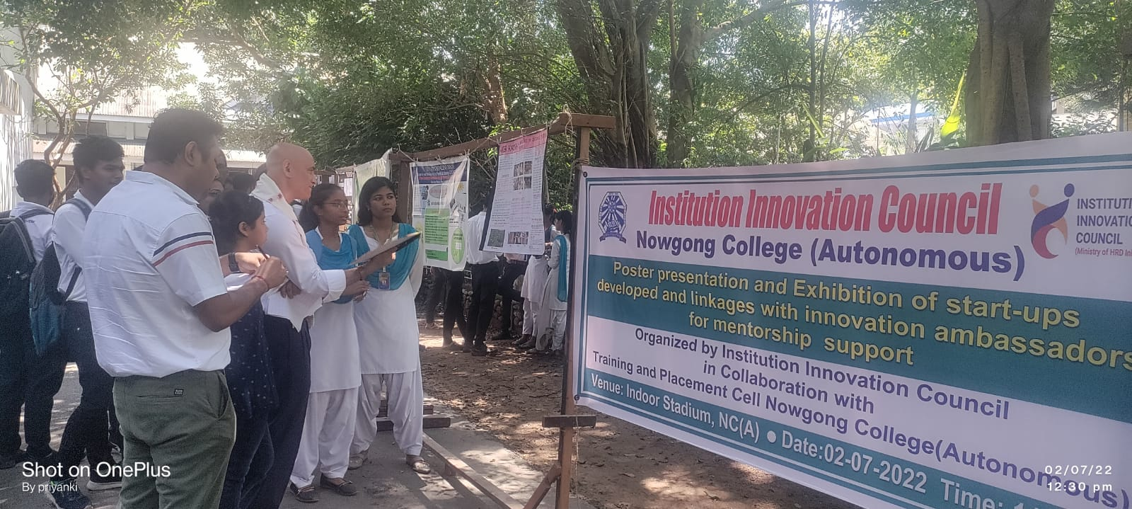

The seminar "Creative Ideas for Creative Entrepreneurs – A Business Idea Competition" provided a platform for aspiring entrepreneurs to showcase innovative business ideas. Organized to foster creativity and entrepreneurial spirit, the event featured keynote speeches by industry experts, workshops on business development, and a competitive pitch session. Participants presented unique, viable, and scalable business concepts, which were evaluated by a panel of experienced judges. The competition encouraged strategic thinking, problem-solving, and networking among attendees. Winners received mentorship opportunities, seed funding, and resources to kickstart their ventures. The seminar successfully inspired entrepreneurial innovation and collaboration among emerging business leaders.

