A Workshop on Career Counseling
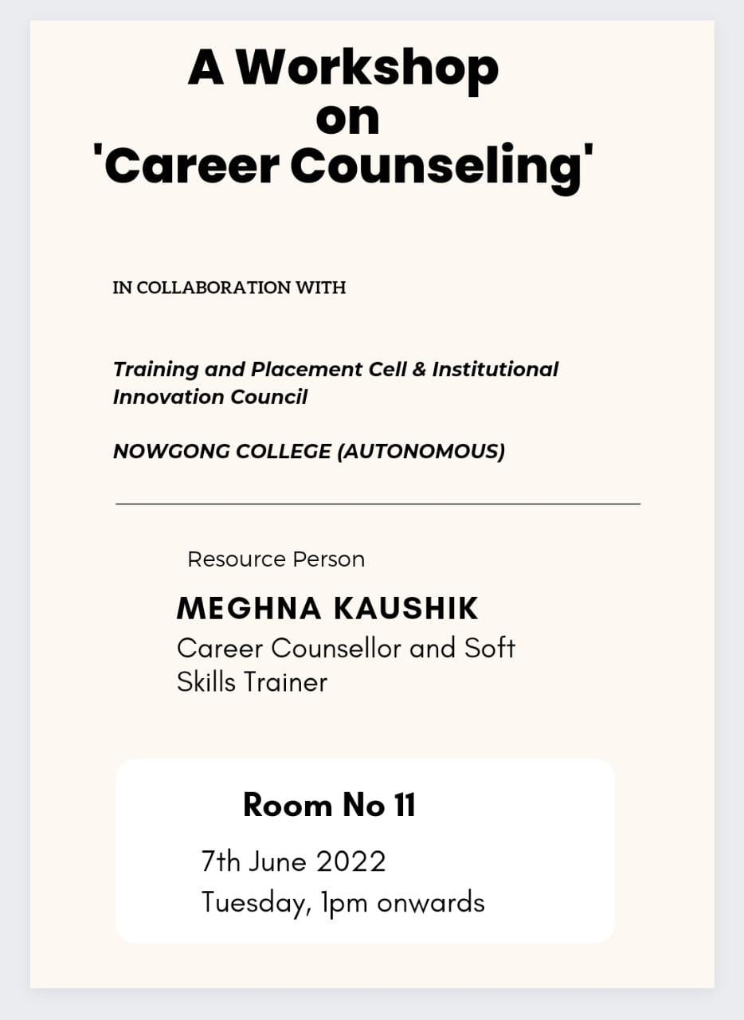

The seminar, "A Workshop on Career Counselling," provided valuable insights into career planning and development for students and young professionals. Organized to address growing concerns about career choices, the workshop featured expert counselors, educators, and industry professionals who shared guidance on identifying strengths, interests, and suitable career paths. The session emphasized the importance of aligning personal skills with market demands, exploring emerging job opportunities, and acquiring necessary qualifications. Interactive discussions and one-on-one counseling sessions enabled participants to clarify doubts and set clear professional goals. Practical tips on resume building, interview preparation, and skill development were also provided. Attendees benefited from motivational success stories and expert advice on navigating competitive job markets. Overall, the seminar proved to be a crucial platform for empowering individuals to make informed career decisions, fostering confidence and readiness to excel in their chosen fields.
