Quicker methods for Competitive Examinations

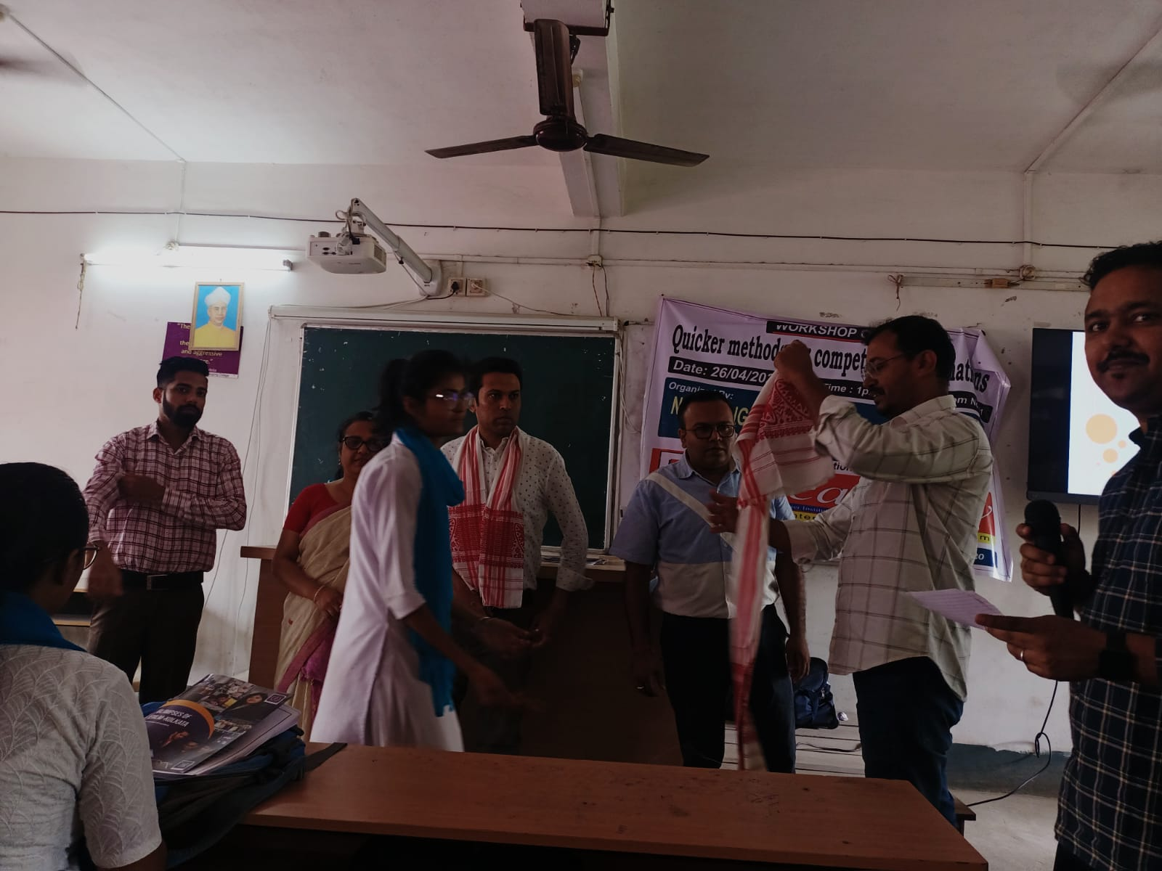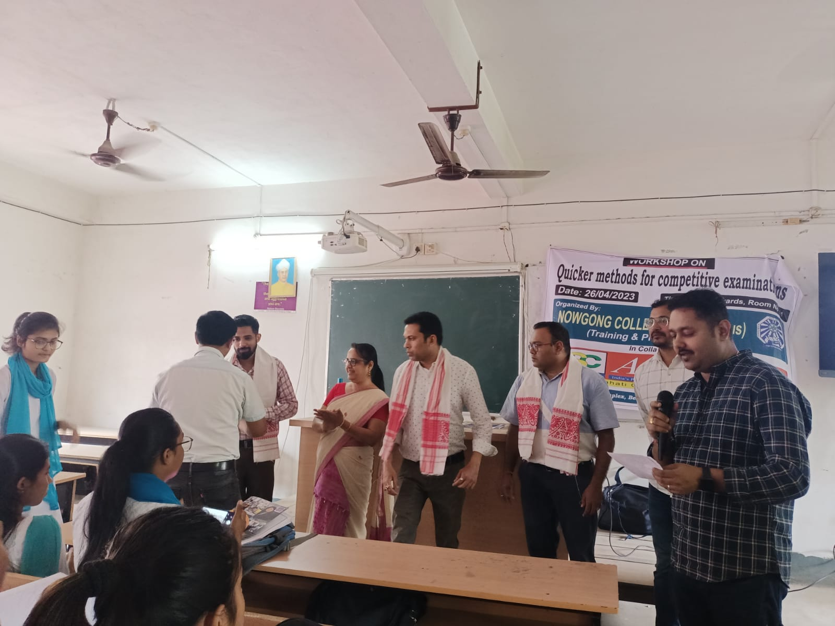
A one-day workshop titled “Quicker Methods of Mathematics” was successfully organized on [date] by the Department of Mathematics, [Institution Name]. The event aimed to equip participants with innovative techniques to solve mathematical problems efficiently, enhancing both speed and accuracy.
The resource person an expert in mathematical shortcuts, introduced concepts such as Vedic Mathematics, mental calculations, and simplified problem-solving approaches.
Around 150 participants, including students and faculty members, actively engaged in interactive sessions, solving practical problems through faster techniques. Feedback from participants highlighted the effectiveness of the program in boosting confidence and problem-solving skills.
The workshop concluded with a vote of thanks by Dr. Rishi Bhargav Das, acknowledging the efforts of the organizing team and the enthusiasm of the attendees. The event was both informative and highly appreciated.

