Employability Skills & scopes of Management Education EIILM, Kolkata
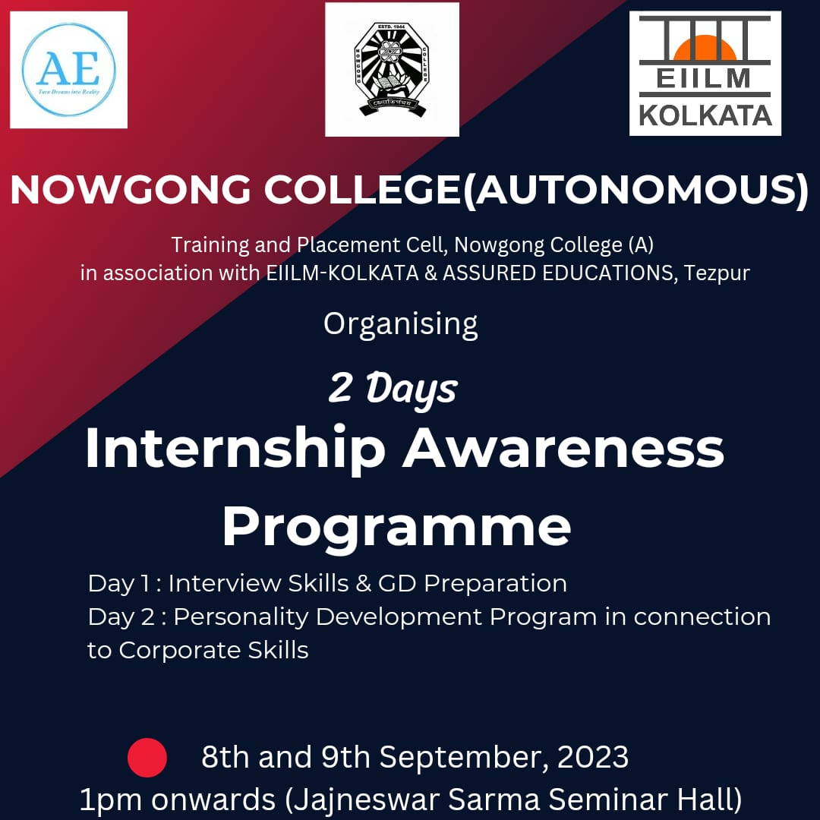

Eastern Institute for Integrated Learning in Management (EIILM), Kolkata, is renowned for fostering employability through its dynamic management education programs. The institute emphasizes practical knowledge, industry exposure, and skill development, equipping students to meet corporate demands effectively.
Key employability skills developed include leadership, critical thinking, communication, and problem-solving, integrated into their curriculum through case studies, internships, and live projects. EIILM’s strong industry connections and placement cell ensure students receive exposure to top companies and emerging sectors.
The scope of management education at EIILM extends across diverse fields like marketing, finance, human resources, and entrepreneurship. Graduates find opportunities in multinational corporations, startups, and government organizations. EIILM’s focus on innovation and global business trends positions students to excel in competitive markets.
With a commitment to academic excellence and holistic development, EIILM Kolkata continues to be a preferred destination for aspirants seeking a robust career in management.

