A Workshop on Career Counselling, Vocational Guidance and Self Employment Programme

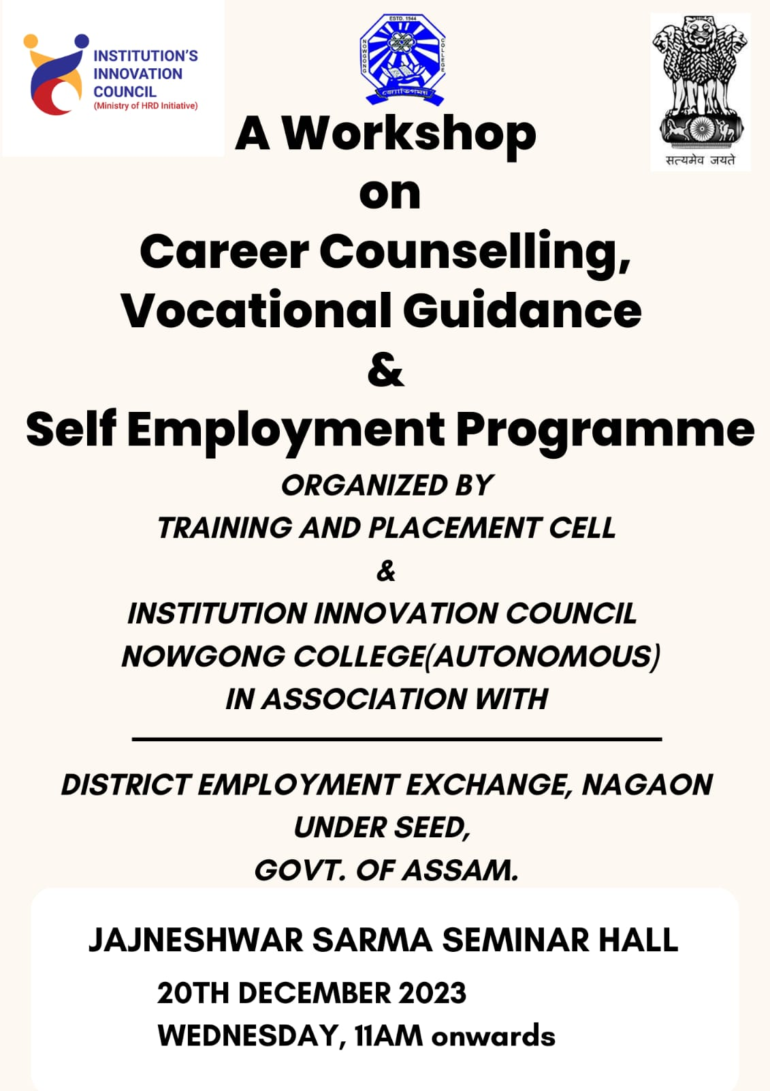

The workshop featured expert speakers from various fields who provided insights into emerging career opportunities, skill development, and entrepreneurship. Sessions included interactive discussions on self-assessment, vocational training options, and the benefits of self-employment. Practical activities, such as resume building and mock interviews, enhanced the participants' learning experience.
Over 200 students actively participated, showcasing enthusiasm and curiosity. Feedback highlighted the workshop's relevance in bridging the gap between academic knowledge and real-world applications.
The program concluded with a motivational talk, emphasizing the importance of self-confidence and adaptability in a dynamic job market. Participants expressed gratitude for the valuable guidance and resources provided.
