Launch of JIO 5G and Students Knowledge System
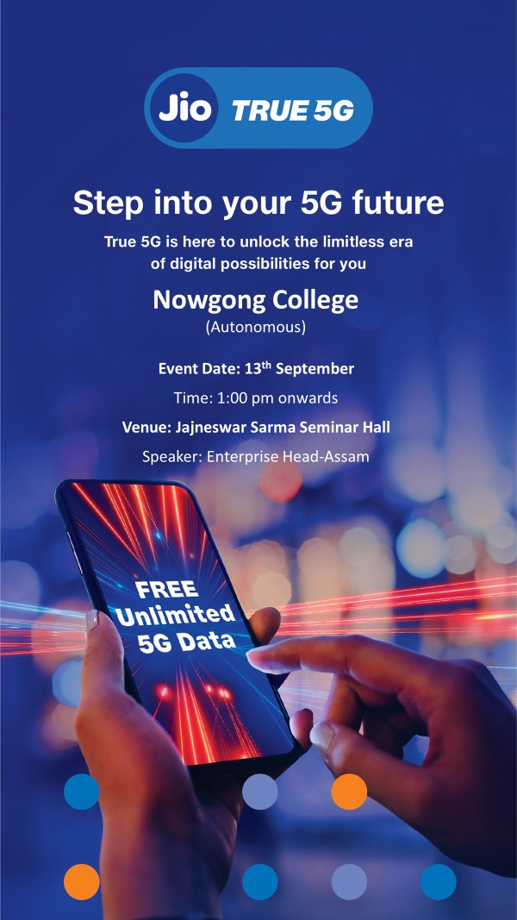
The launch of JIO 5G, India’s most advanced wireless technology, marks a significant step in the country’s digital transformation. Officially unveiled on 13th September 2023, JIO 5G promises ultra-fast internet speeds, low latency, and widespread connectivity, revolutionizing communication and technology access. This advancement particularly benefits the education sector by enabling innovations like the Students Knowledge System.
The Students Knowledge System integrates JIO 5G technology to provide seamless access to online learning platforms, digital libraries, virtual classrooms, and immersive education tools like augmented and virtual reality. With enhanced internet speed, students in rural and urban areas alike can experience equitable access to high-quality educational content, bridging the digital divide.
The initiative aligns with the vision of a digitally empowered India, fostering inclusivity and innovation in education. By empowering students with cutting-edge tools, it ensures a brighter future for India’s youth in the global knowledge economy.
