Competitive Examination- IAS and ACS: A Personal Experience by Resource Person: Jishnu Baruah, IAS, Chairman, APDCL, Former Secretary of Assam
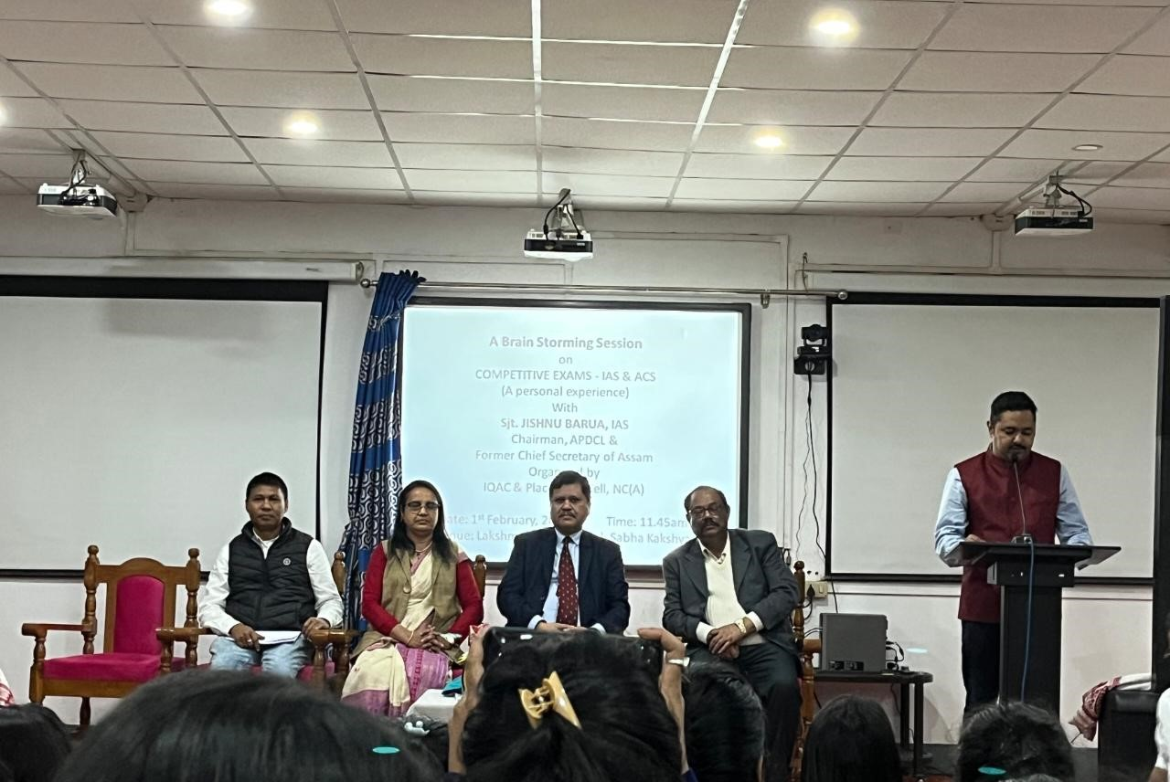
A seminar titled "Competitive Examination - IAS and ACS: A Personal Experience" was conducted and the session was graced by Mr. Jishnu Baruah, IAS, Chairman of APDCL and former Secretary of Assam, as the resource person.
Mr. Baruah shared his insightful journey into civil services, highlighting the rigorous preparation and commitment required for IAS and ACS examinations. He emphasized the importance of time management, understanding the syllabus, and maintaining a focused study routine. Drawing from his personal experience, he advised aspirants to cultivate discipline, critical thinking, and resilience.
He also elaborated on the evolving nature of competitive exams, stressing the significance of staying updated on current affairs and mastering both written and interview skills. The interactive session provided students with valuable tips and motivation to pursue their goals in public administration.
The seminar was highly enriching, leaving a lasting impact on participants.
