A Workshop on New Age Skills Set for a Successful Career: Mr Zulfi Ali Bhutto organised by Pune Institute of Business Management.
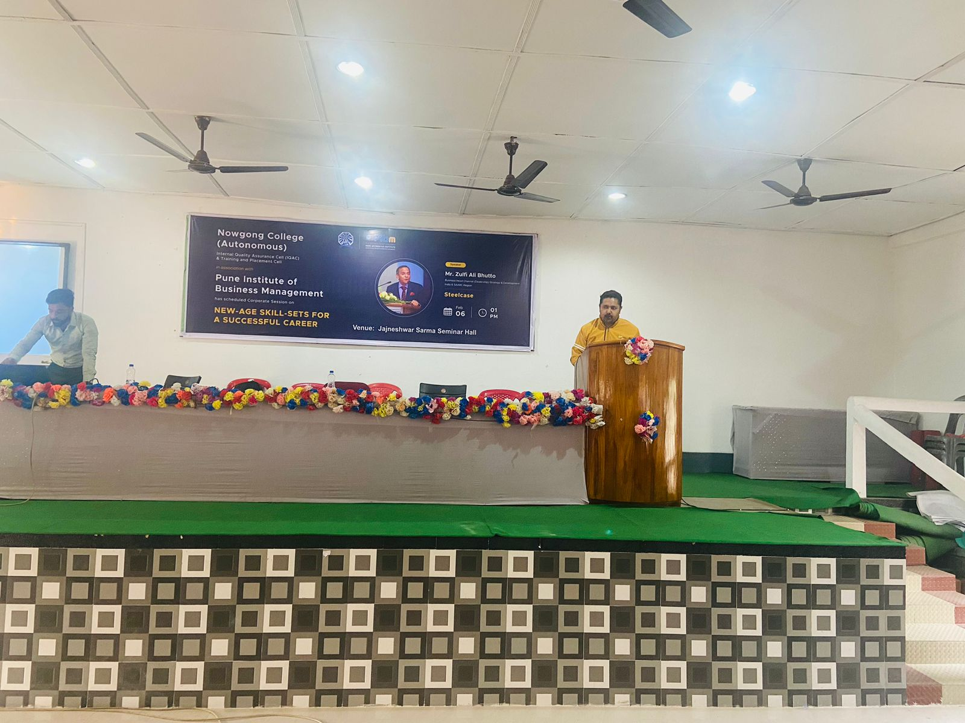
The Pune Institute of Business Management (PIBM) organized an insightful workshop titled "New Age Skill Set for a Successful Career" with Mr. Zulfi Ali Bhutto as the keynote speaker. The workshop aimed to equip students with the essential skills required to excel in the evolving professional landscape.
Mr. Bhutto emphasized the significance of adaptability, critical thinking, and technological proficiency in the era of digital transformation. He elaborated on how skills like data analysis, emotional intelligence, and effective communication are becoming indispensable for career growth. Through interactive discussions, he highlighted real-world scenarios and shared valuable tips on personal branding and networking.
The session concluded with a Q&A segment, where students actively engaged with Mr. Bhutto, seeking guidance on career challenges. The workshop proved highly beneficial, inspiring participants to embrace continuous learning and innovation for a successful career trajectory.
