A Workshop on Soft Skills, Entrepreneurship and Innovative Design: Resource Person: Meghna Kaushik
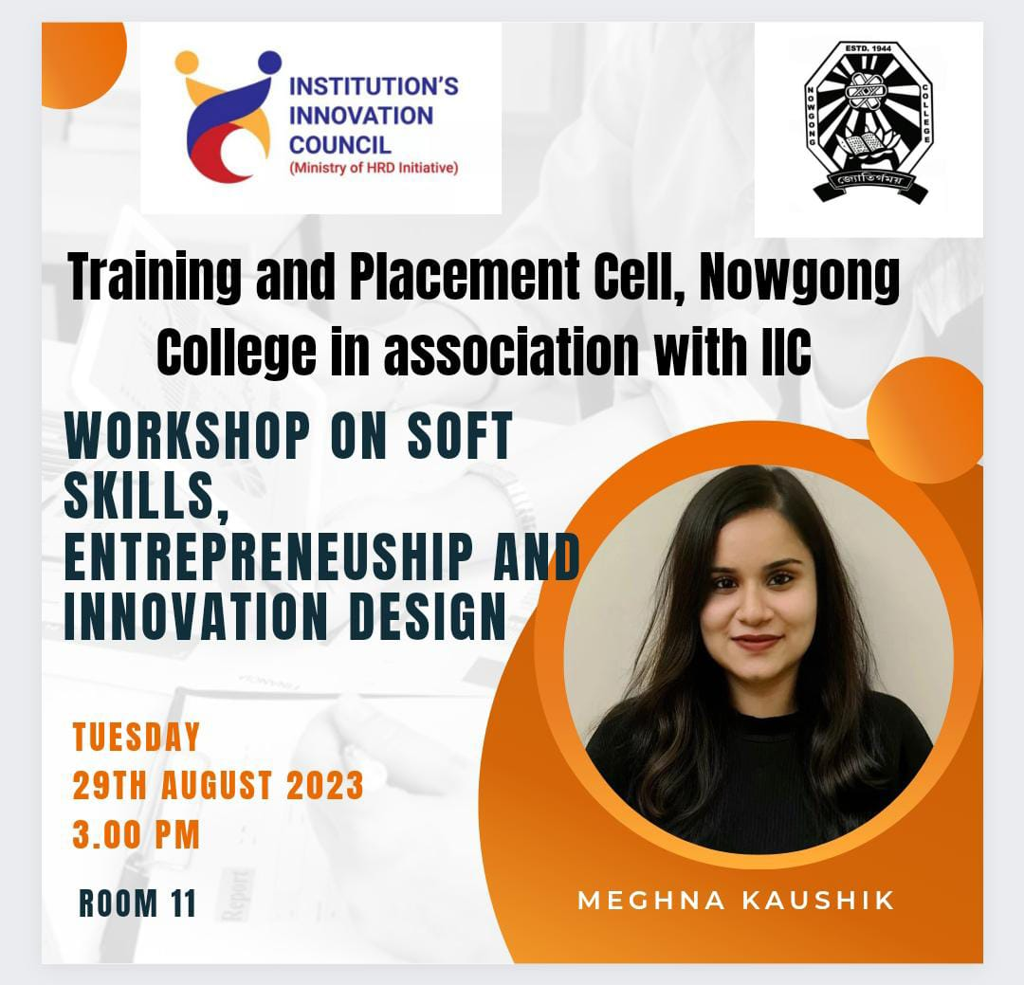
A workshop titled "Soft Skills, Entrepreneurship, and Innovative Design" was conducted on 29.8.23 with Ms. Meghna Kaushik as the esteemed resource person. The session aimed to equip participants with essential skills for professional growth and entrepreneurial success.
Ms. Kaushik, an expert in entrepreneurship and innovative design, emphasized the importance of effective communication, teamwork, and creativity in achieving personal and organizational goals. She provided insightful strategies on fostering innovation, identifying entrepreneurial opportunities, and developing a design-thinking mindset.
The interactive nature of the workshop engaged participants through real-world case studies, group activities, and discussions. Attendees were motivated to enhance their adaptability and problem-solving skills, vital in today’s competitive landscape.
The workshop concluded with positive feedback from participants, who appreciated the practical insights and relevance of the topics covered. Overall, it was a highly enriching and impactful session that inspired innovation and skill development.
