How to achieve your career goals? A Career Guidance Programme organised by Takshashila: School of Civil Services. (Exclusively for UPSC)
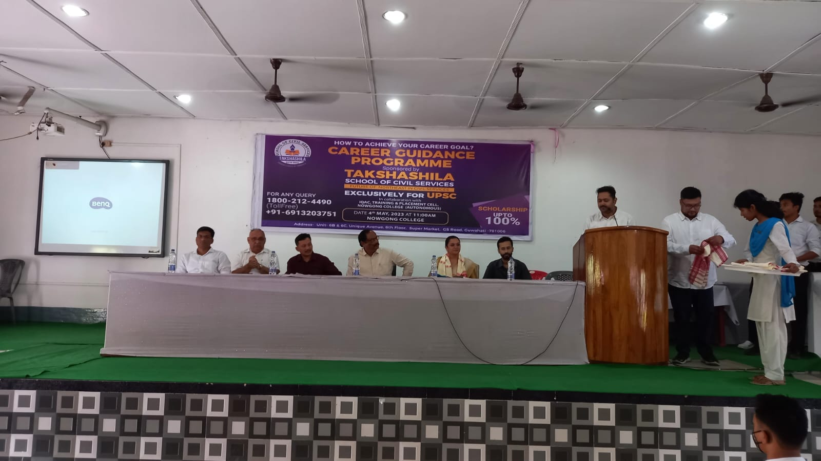
A career guidance programme titled "How to Achieve Your Career Goals?" was organized by Takshashila: School of Civil Services on 4.5.23 exclusively for UPSC aspirants. The session aimed to provide participants with practical strategies and insights to excel in their journey toward a career in civil services.
The keynote speaker, a renowned UPSC mentor, highlighted the importance of setting realistic goals, maintaining discipline, and developing a structured study plan. The session emphasized building a strong foundation in subjects, staying updated on current affairs, and practicing answer-writing for mains.
Interactive segments allowed attendees to clarify doubts on syllabus coverage, time management, and interview preparation. Motivational anecdotes from successful candidates inspired the audience to persevere despite challenges.
The programme concluded with actionable takeaways for consistent preparation, boosting participants' confidence in their ability to achieve their career aspirations. It was a highly enriching experience for all attendees.
