2 Days Workshop on Banking Examination : TIME Institute: Adeep Rajkhowa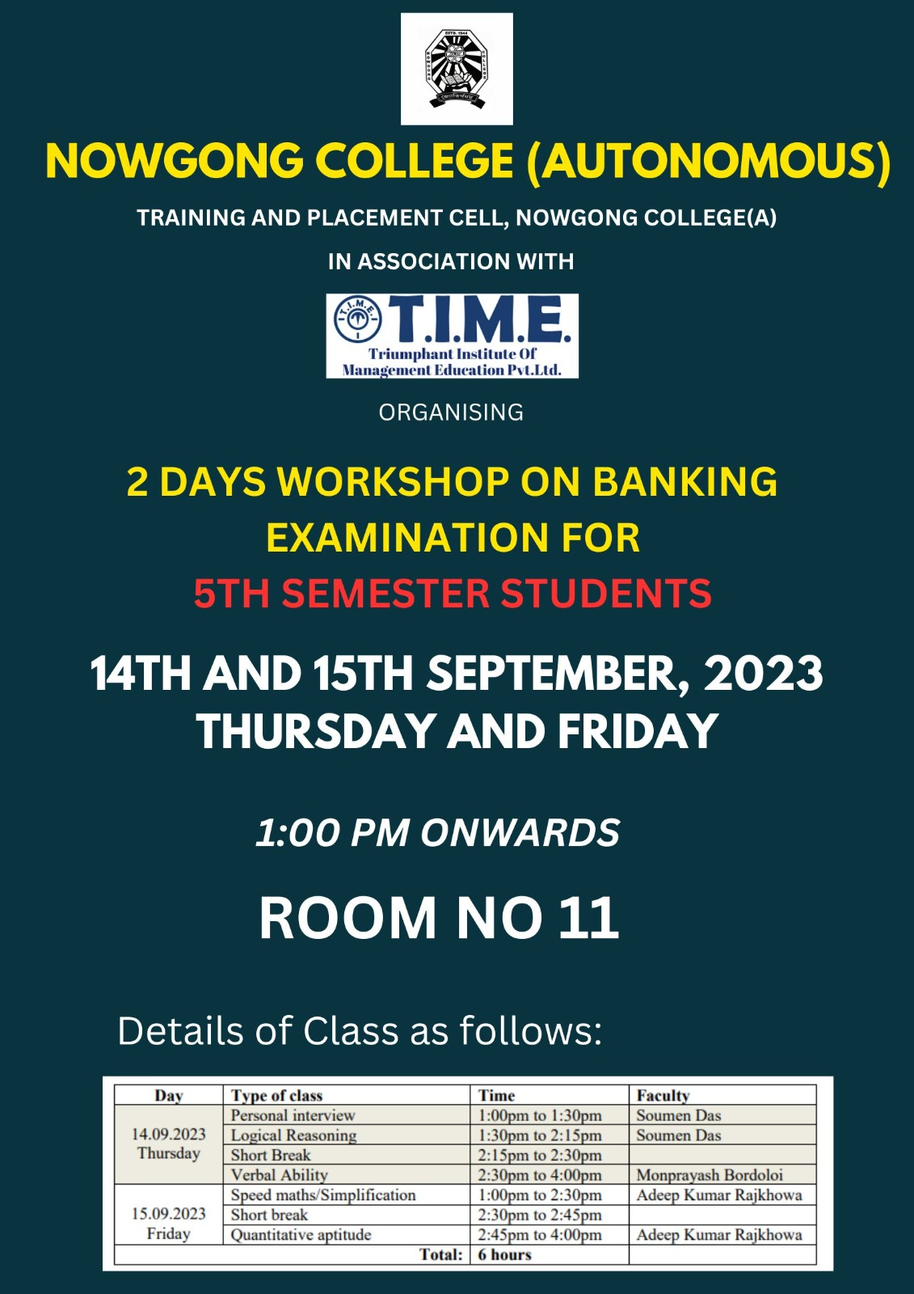

The session covered a wide array of topics essential for banking exams, including quantitative aptitude, reasoning ability, general awareness, and English language skills. Experienced trainers and subject matter experts led the discussions, providing insightful strategies to approach different sections of the examination efficiently.
Interactive sessions allowed participants to engage in practical problem-solving and mock tests, enhancing their exam readiness. The workshop also included a session on time management techniques and stress management during exams, ensuring candidates are mentally prepared for the rigorous selection process.
The event concluded with a Q&A session, where participants clarified their doubts. Overall, the workshop was a success, equipping candidates with the necessary skills and confidence to excel in banking exams.
