ONE DAY WORKSHOP ON PRINCIPLES OF INVESTING ORGANISED BY BOMBAY STOCK EXCHANGE IN COLLABORATION WITH DEPARTMENT OF COMMERCE, NOWGONG COLLEGE(AUTONOMOUS), NAGAON, DATED 11.03.2024
RESOURCE PERSON: MARINA JOSE, BOMBAY STOCK EXCHANGE

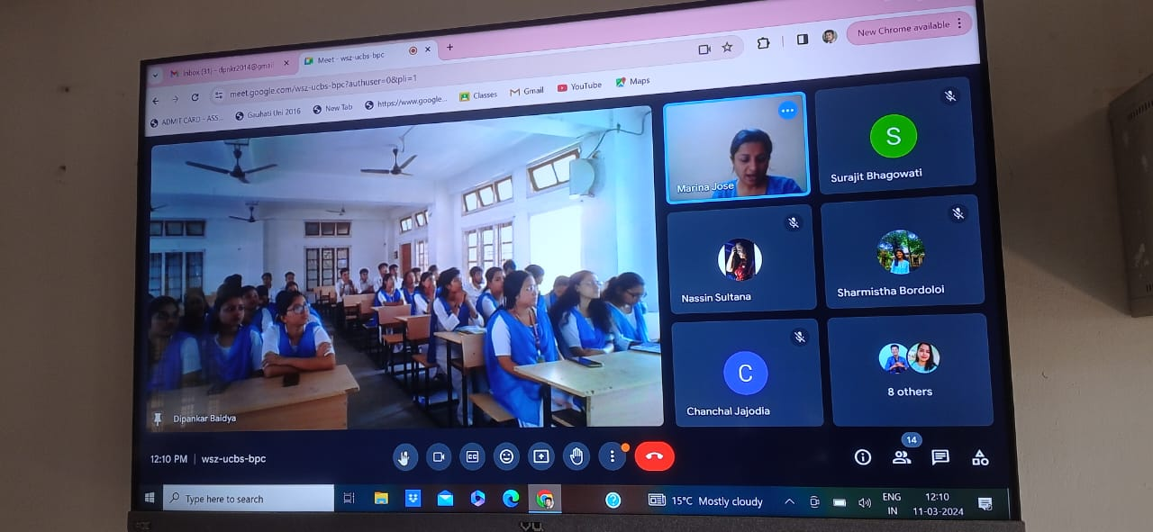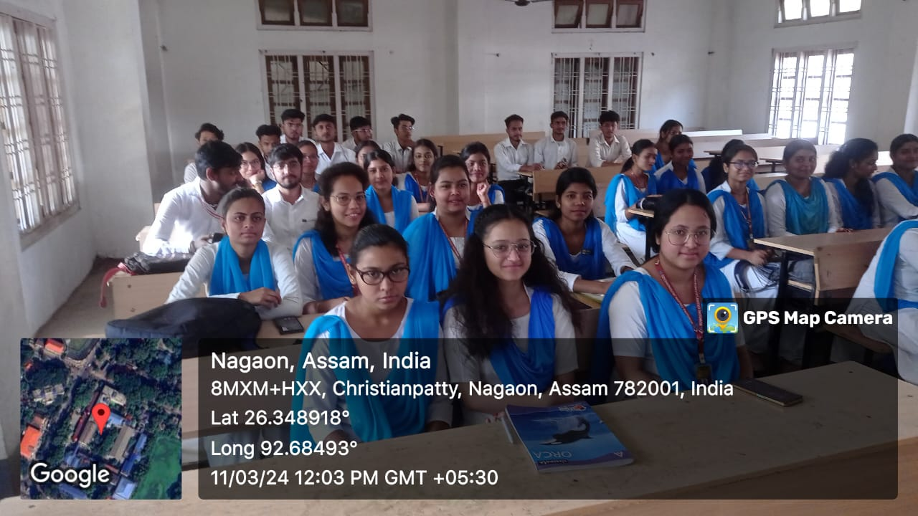
The Department of Commerce at Nowgong College (Autonomous), in collaboration with the Bombay Stock Exchange (BSE), successfully organized a one-day workshop on the Principles of Investing. The workshop aimed to impart foundational knowledge and practical insights into investment strategies and financial planning to students, faculty, and budding investors. This initiative reflects the shared commitment of both institutions to empower individuals with the financial literacy required for informed decision-making in today’s dynamic economic environment.
Outcome: The workshop successfully achieved its objectives by equipping participants with:
- A clear understanding of various investment vehicles and their associated risks.
- Practical knowledge of stock market functioning and trading processes.
- Awareness of the importance of early and systematic investment planning for achieving financial goals.
- A framework for making informed and ethical investment decisions.

