One day Workshop on Market Opportunities and Career Options
By PIBM 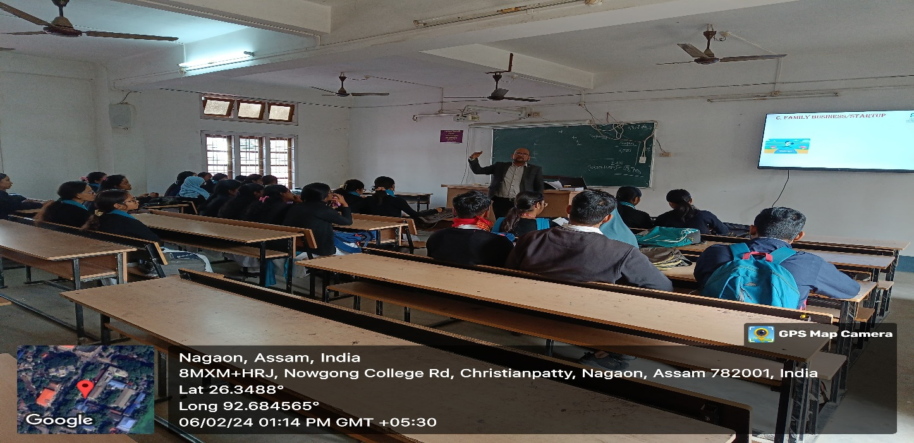

The event aimed to bridge the gap between academic knowledge and industry requirements, providing attendees with insights into emerging market trends and career pathways.
The workshop featured keynote speeches by industry experts, interactive sessions, and panel discussions on topics such as entrepreneurship, skill development, and global market dynamics. Participants explored various sectors, including technology, healthcare, and e-commerce, highlighting growth opportunities.
Hands-on activities, including resume-building and mock interviews, provided practical guidance to job seekers. Entrepreneurs received valuable advice on business planning and networking. The interactive Q&A sessions fostered engagement, addressing participants' queries and concerns.
The event concluded with a motivational address emphasizing adaptability and continuous learning. Feedback from attendees praised the workshop as informative and inspiring, marking it as a significant success.