An Awareness Programme on PM Internship Programme
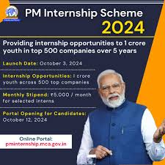
An awareness programme on the Prime Minister's Internship Programme was conducted on 5th November to familiarize students and young professionals with this flagship initiative. The event witnessed the participation of 100 attendees, including students, educators, and aspiring interns.
The programme began with a, highlighting the objectives of the internship, which aims to provide practical exposure to policymaking, governance, and development projects under the mentorship of government officials. A detailed presentation outlined the application process, eligibility criteria, and key benefits such as skill development, networking opportunities, and a certificate of participation.
Interactive sessions allowed participants to clarify doubts and hear testimonials from previous interns who shared their enriching experiences. The event concluded with a call to action, encouraging attendees to seize this opportunity to contribute to nation-building while advancing their careers. Feedback from participants reflected enthusiasm and eagerness to apply.
