Skill Yatra Skill Awareness Programme- Assam Skill Development Mission
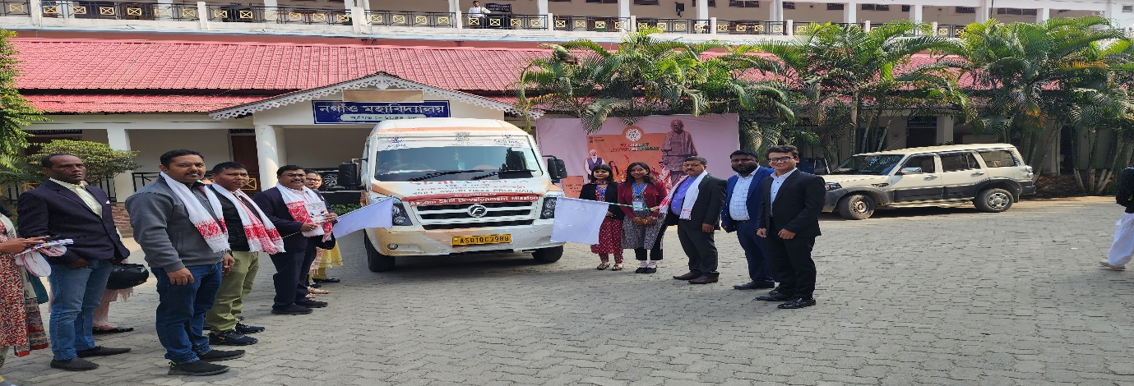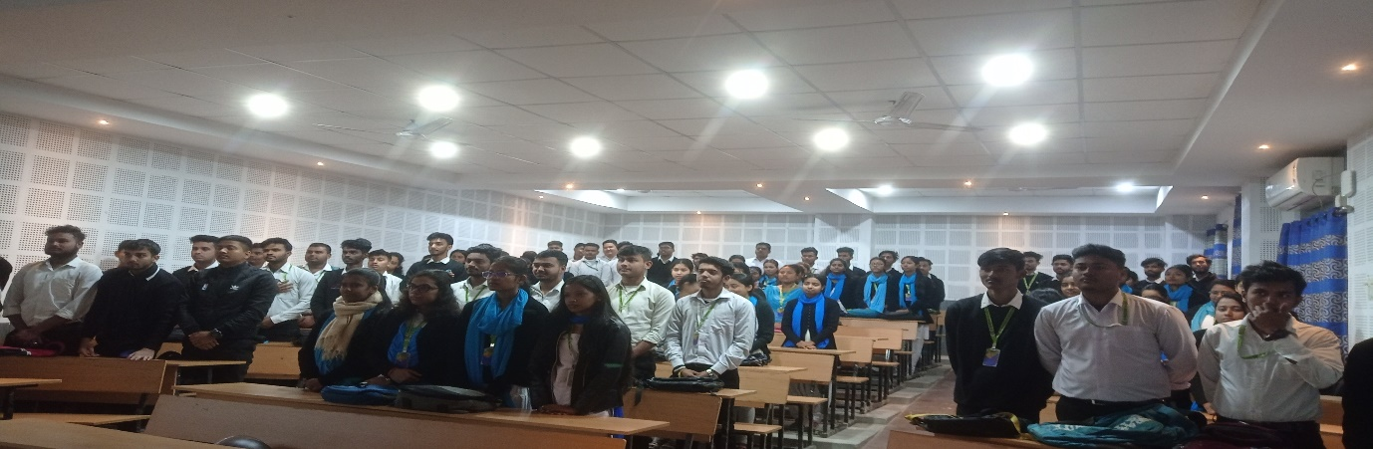

The Assam Skill Development Mission (ASDM) organized the Skill Yatra Skill Awareness Programme to promote vocational training and employment opportunities across Assam. The event aimed to raise awareness about skill development initiatives, focusing on empowering youth with job-ready capabilities.
Held in multiple districts, the programme featured interactive sessions, career counseling, and demonstrations of skill-based trades. Experts provided insights into diverse sectors such as hospitality, healthcare, IT, and entrepreneurship. Participants were introduced to government-sponsored training modules and certification programs, enhancing their employability prospects.
The initiative successfully motivated hundreds of youth to enroll in skill development courses, bridging the gap between education and employment. It emphasized inclusive growth, targeting underprivileged and rural populations.
The Skill Yatra reinforced ASDM’s vision of a skilled workforce, contributing to Assam’s economic growth and sustainable development. Feedback highlighted its role in transforming lives through skill-based learning.

