Training Programme for Competitive Examination BY SPM Academy
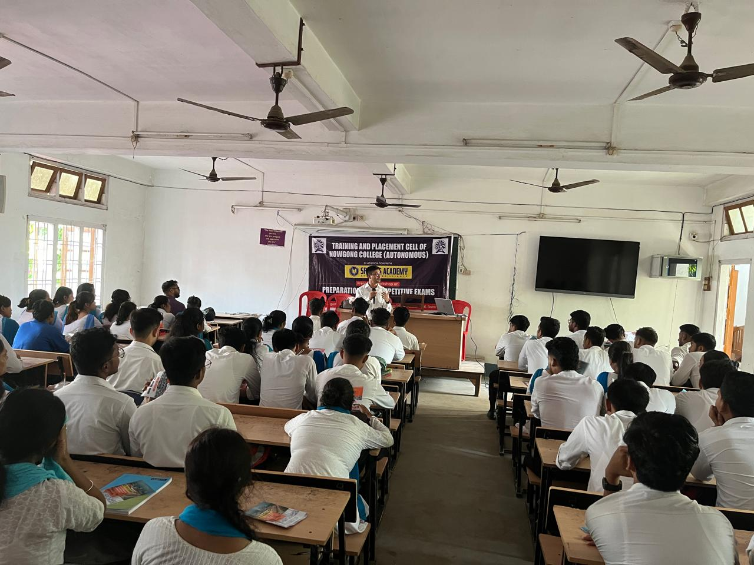

SPM Academy recently conducted a comprehensive training programme aimed at preparing students for competitive examinations. The programme, to provided intensive coaching sessions focusing on aptitude tests, logical reasoning, general awareness, and subject-specific topics. Expert faculty members delivered interactive lectures, personalized mentoring, and practical tips to enhance problem-solving skills.
Participants also benefited from mock tests, group discussions, and interview preparation modules designed to boost confidence and time management abilities. The academy incorporated the latest exam patterns and question formats, ensuring candidates were well-prepared for real-time challenges.
Feedback from attendees highlighted the effectiveness of the training methods and the motivational approach adopted by the instructors. Overall, the programme proved to be a valuable initiative, equipping aspirants with the tools needed to excel in competitive examinations.
