Mera Bill Mera Adhikar- organised by GST Department, Nagaon
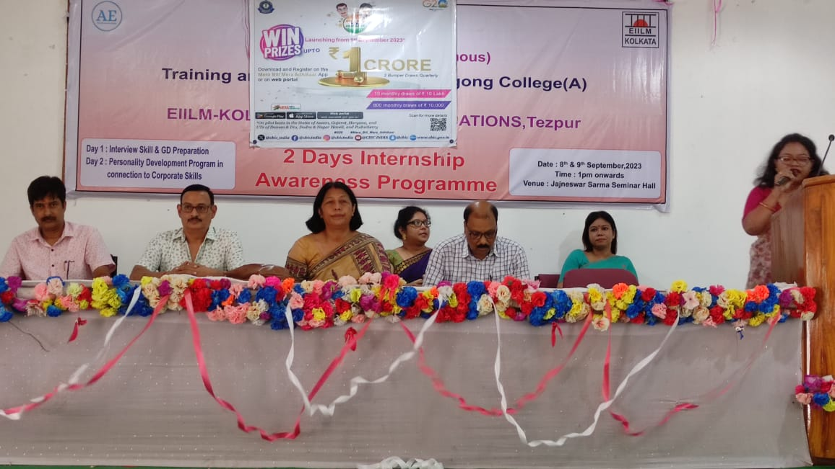
The GST Department, Nagaon, organized a workshop titled 'Mera Bill Mera Adhikar' to promote consumer awareness and tax compliance. Held on [insert date], the event aimed to educate the public about the importance of obtaining bills and invoices for every purchase. Officials highlighted how proper billing strengthens transparency, prevents tax evasion, and safeguards consumer rights.
The workshop featured interactive sessions, demonstrations, and quizzes to engage participants. Attendees were informed about the 'Mera Bill Mera Adhikar' initiative, which encourages consumers to demand bills through incentives and rewards.
Local traders, business owners, and students actively participated, gaining insights into GST regulations and their role in fostering a fair tax system. The event concluded with a Q&A session, addressing queries related to GST compliance.
The workshop emphasized the collective responsibility of citizens in ensuring accountability and strengthening India’s tax structure.

