ENTREPRENUERSHIP AWARNESS PROGRAMME(EAP) ON 24TH February 2025.
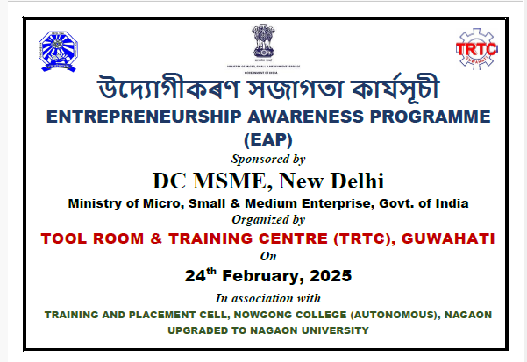
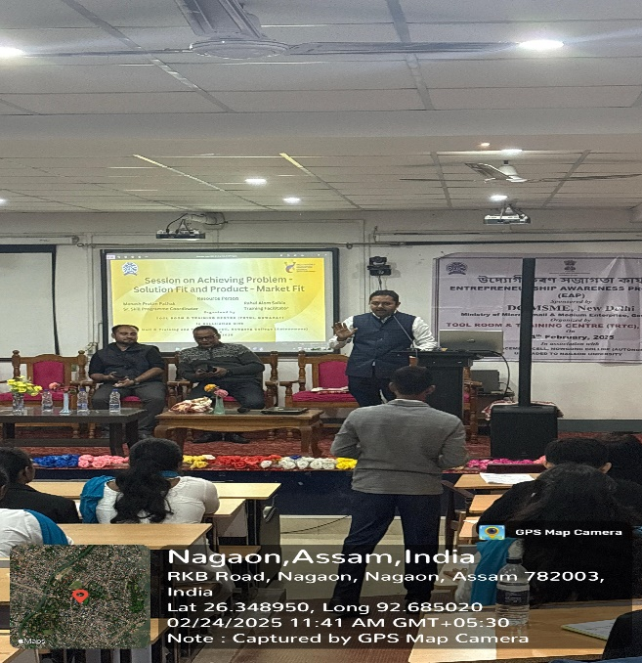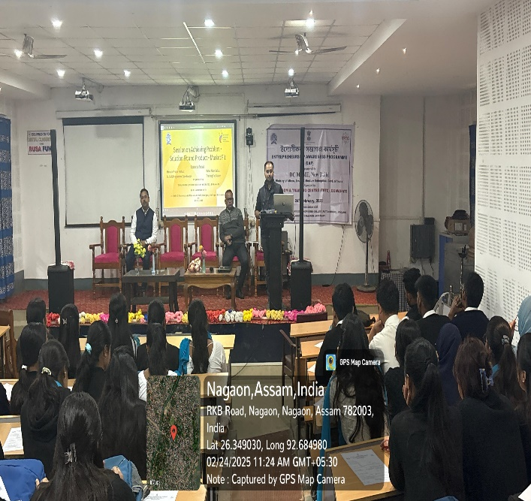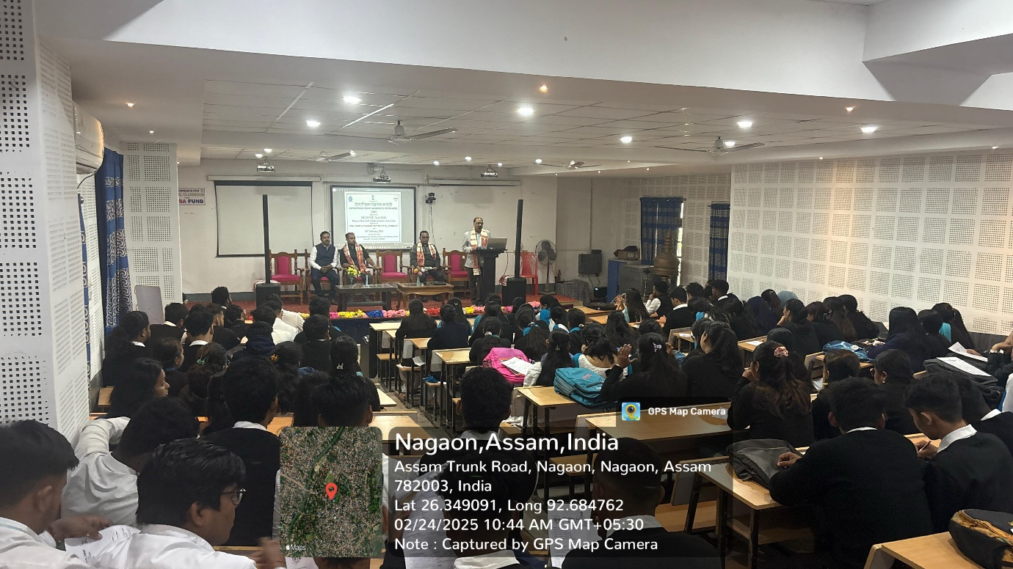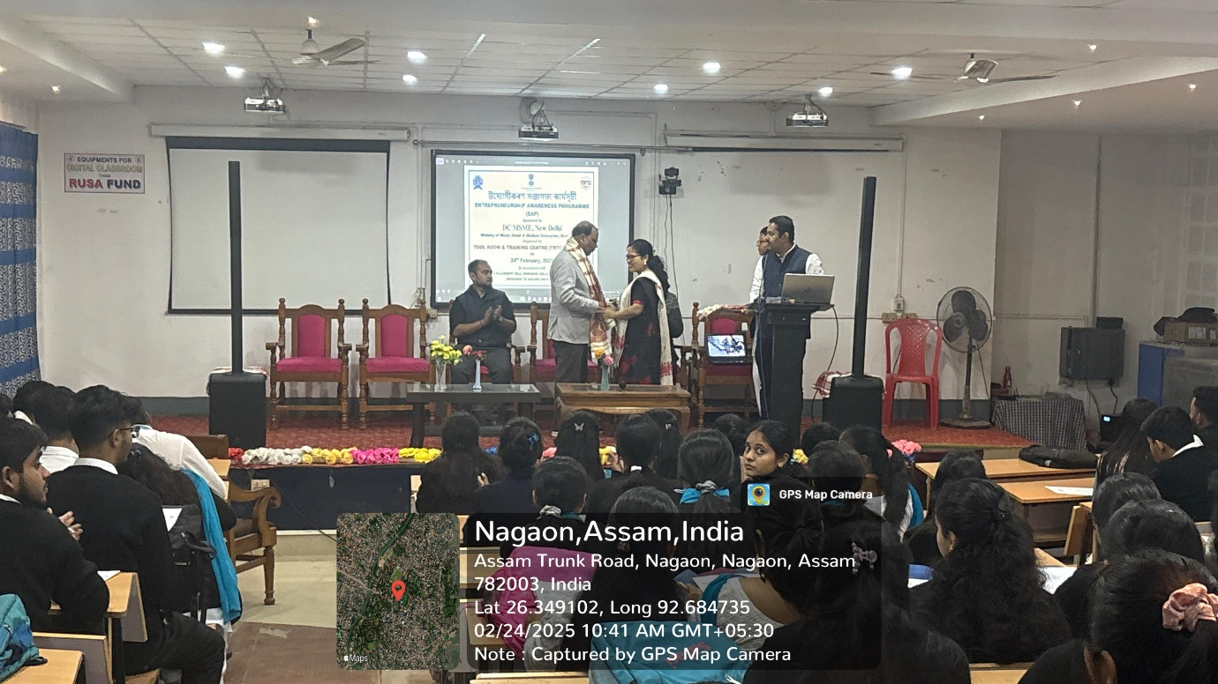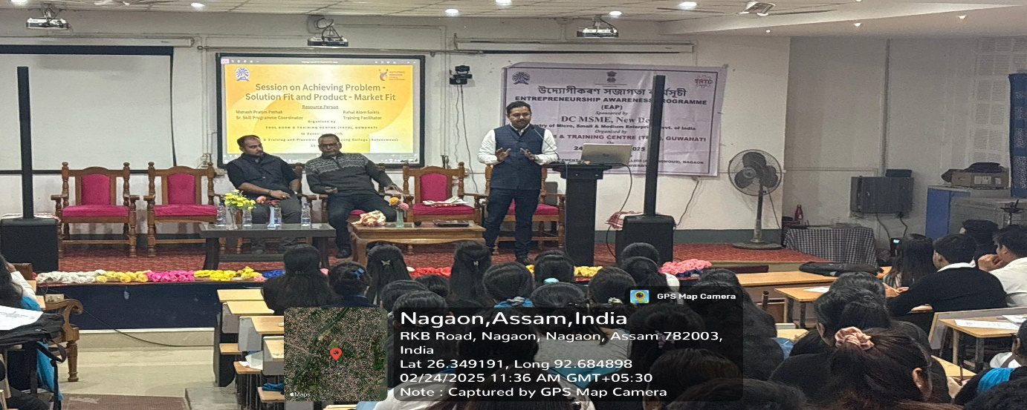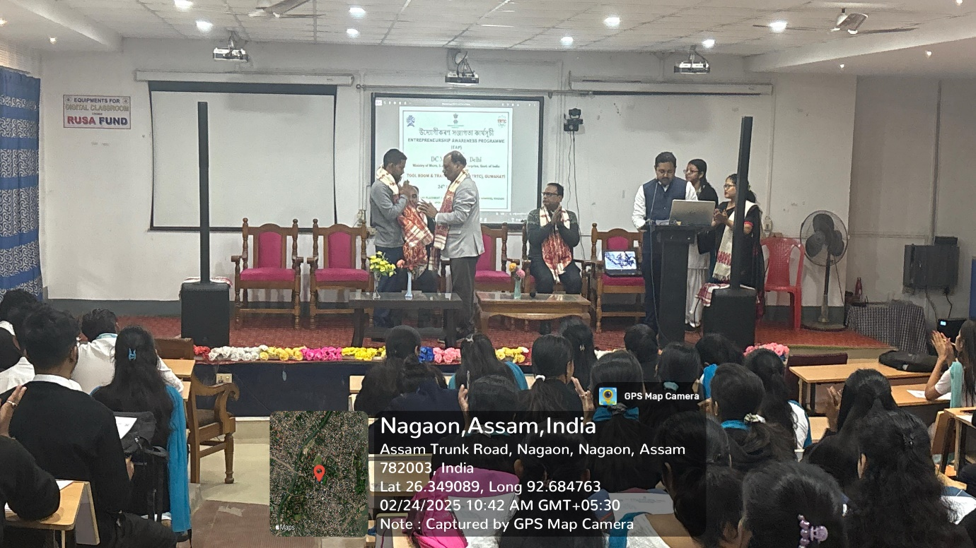

The Entrepreneurship Awareness Programme (EAP) was successfully organized by the Tools Room and Training Centre (TRTC), Guwahati on 25th February 2025. The event aimed to foster an entrepreneurial mindset among aspiring business leaders, students, and young professionals by providing them with essential knowledge about entrepreneurship, business development, and industrial opportunities.
The programme featured expert speakers from diverse sectors, including government officials, industry leaders, and successful entrepreneurs, who shared valuable insights on business planning, startup financing, skill development, and market strategies. Additionally, the participants were introduced to the various support schemes provided by the Ministry of Micro, Small & Medium Enterprises (MSME) and other financial institutions to encourage entrepreneurship.
Interactive sessions, case studies, and real-life examples were incorporated to make the programme more engaging and informative. The event also emphasized the importance of technical skills, innovation, and digital transformation in modern entrepreneurship.
This initiative by TRTC Guwahati reinforced its commitment to nurturing entrepreneurial talent and supporting the economic development of the region by equipping individuals with the necessary tools and knowledge to start and sustain their ventures successfully.

