Campus Recruitment- SBI LIFE Nagaon
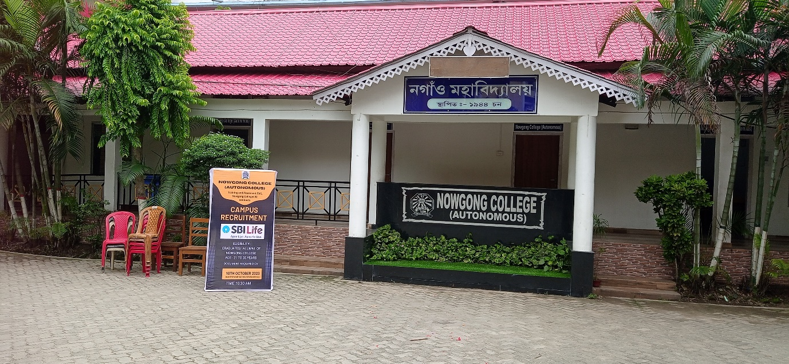
The campus recruitment drive by SBI Life was successfully conducted and the event aimed to provide placement opportunities for final-year students from various disciplines.
The recruitment process began with an informative presentation by the SBI Life team, highlighting the organization's growth, career prospects, and work culture. This was followed by an aptitude test, group discussion, and personal interviews to assess the candidates' technical and interpersonal skills.
A total of 45 students participated in the drive, with 15 being shortlisted for final selection. The selected candidates were offered positions in sales, operations, and customer relations, with attractive salary packages and growth opportunities.
The recruitment drive served as a significant platform for students to embark on their professional journeys. The institution expressed gratitude to SBI Life for their collaboration and commitment to empowering young talent.
