Campus Recruitment by Kotak Life Insurance
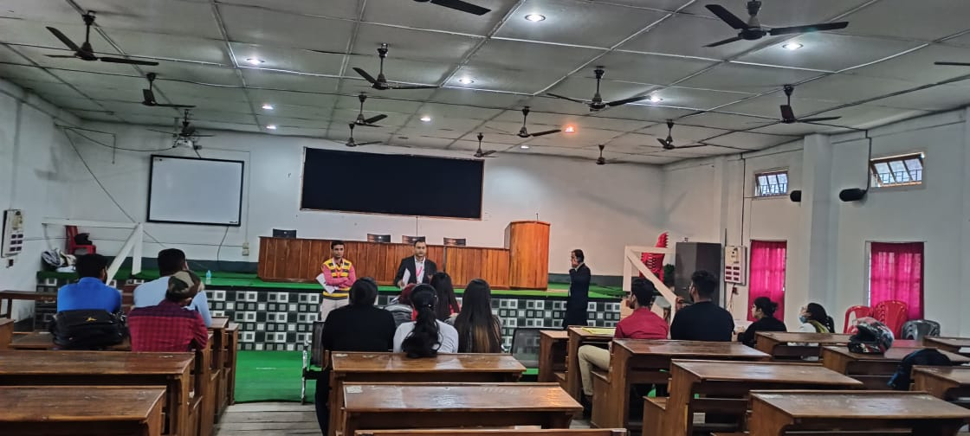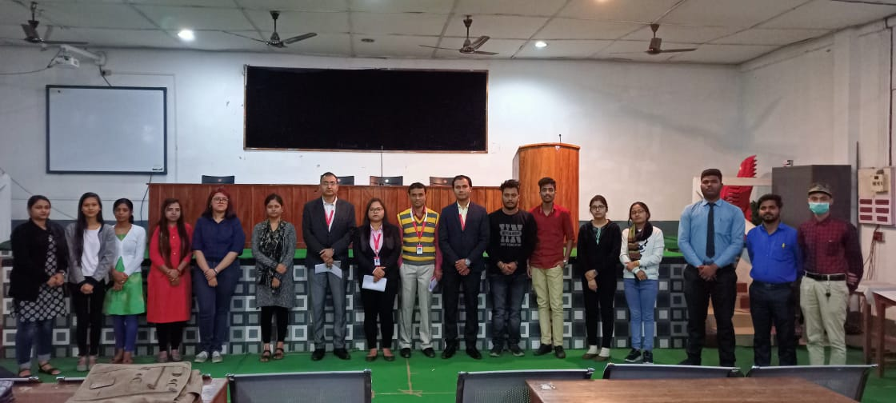
Kotak Life Insurance conducted a campus recruitment drive, offering exciting career opportunities for graduates. The event began with a company presentation highlighting Kotak Life’s vision, mission, and growth trajectory in the insurance sector. Representatives emphasized the organization’s focus on innovation, customer-centric services, and professional development.
Students underwent a rigorous selection process, including an aptitude test, group discussions, and personal interviews. The recruiters assessed candidates’ communication skills, analytical thinking, and problem-solving abilities.
Successful candidates were offered roles in sales, customer relations, and financial advisory services, with competitive salary packages and performance-based incentives. Kotak Life also promised structured training programs and mentorship opportunities to help recruits transition smoothly into their roles.
The recruitment drive concluded with an interactive Q&A session, where students gained insights into the industry and growth prospects. Overall, the event was well-received, fostering enthusiasm among aspiring professionals to build careers with Kotak Life Insurance.

